

CMM3 PAST PAPERS

YIPPEEE



Contents

2017 Past Paper 3

Question 1 3

Answer 1a) 4

Answer 1b) 4

Answer 1c)d) 5

2018 Past Paper 6

Question 2 6

Answer 2c) 7

Question 3 8

Answer 3a) 8

Answer 3b) 9

2019 Past Paper 10

Question 1 10

Question 2 10

Answer 2a)b) 10

Question 3 10

Question 4 11

Answer 4 12

Question 5 13

Answer 5 13

2020 Past Paper 14

Question 1 14

Answer 1a) 14

Question 2 15

Answer 2 16

Question 3 17

Answer 3 18

Question 4 18

Answer 19

Question 5 20

Answer 20

2021 Past Paper 21

Question 1 (Same as 2019 Question 1) 21

Answer 1a) 22

Answer 1b) 22

Question 2 (Same as 2019 Question 3) 23

Answer 2 23

Question 3 24

Answer 3a) 25

Answer 3b) 25

Answer 3c) 26

Answer 3d) 27

Question 4 28

Answer 4a) 29

Answer 4b) 30

Answer 4c)d) 32

2022 Past Paper 33

Question 1 33

Answer 1a) 33

Question 1b) 34

A white text with black textDescription automatically generated 34

Question 2 35

Answer 2b) 37

Answer 2c) 43

Question 3 45

Answer 3a) 45

Question 4 46

Answer 4a) 47

Answer 4b)c)d) 47

# 2017 Past Paper

## Question 1

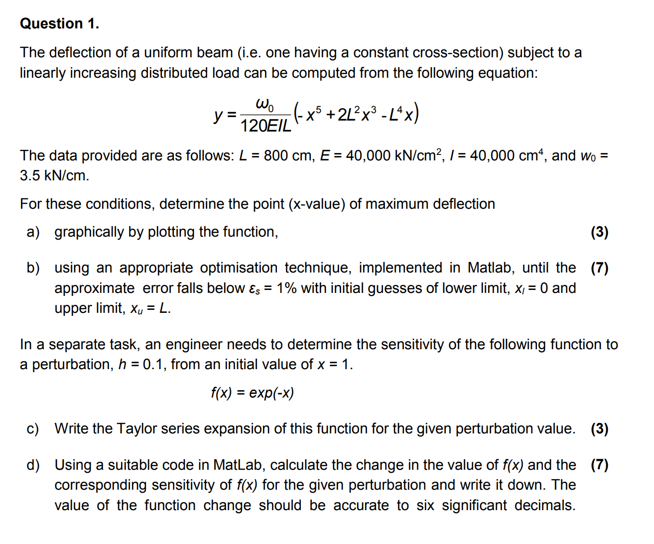

### Answer 1a)

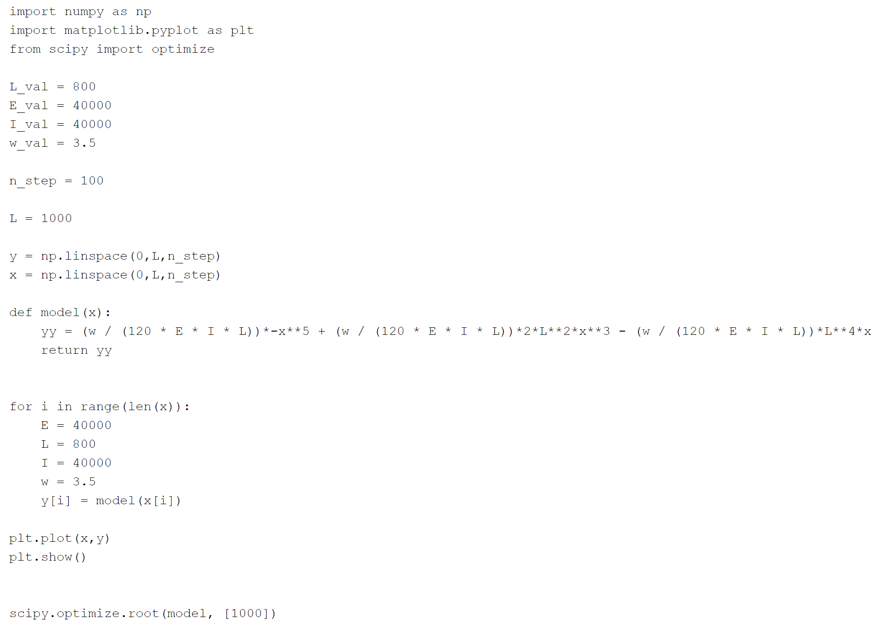

### Answer 1b)

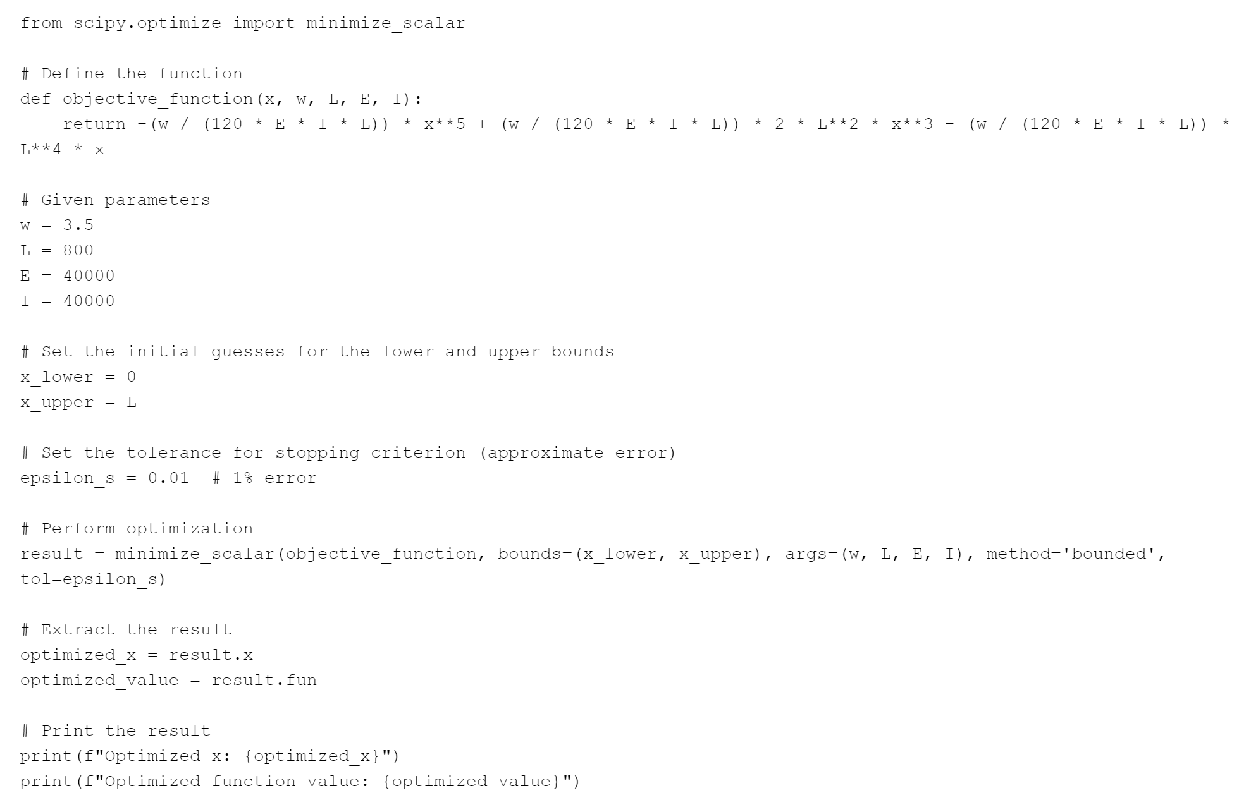

### Answer 1c)d)

~~~~ Emailed and don’t think taylor series will be asked~~~~~

# 2018 Past Paper

## Question 2

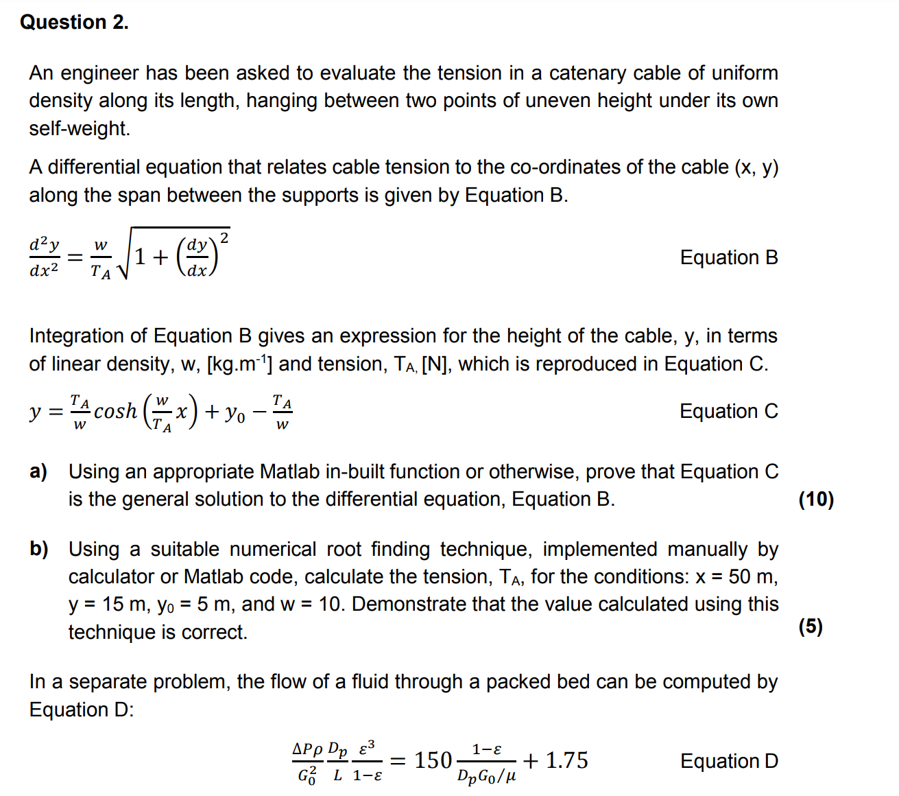

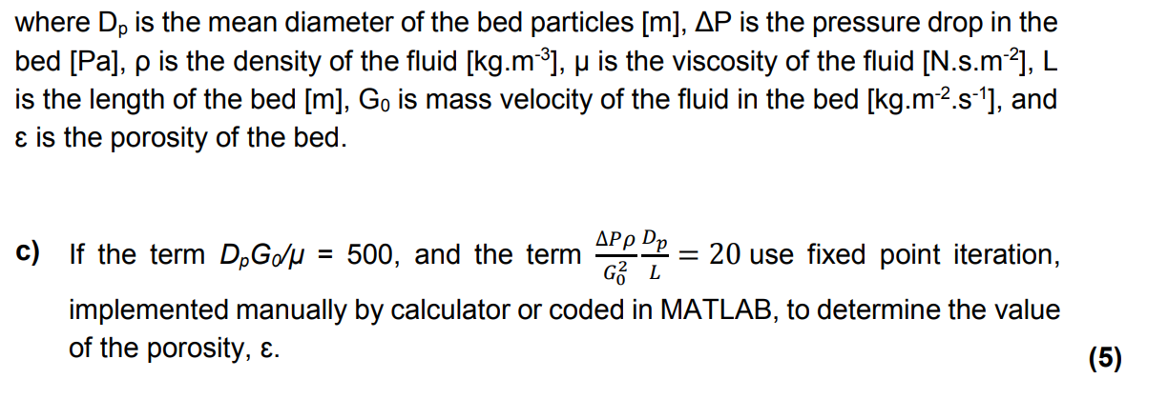

### Answer 2c)

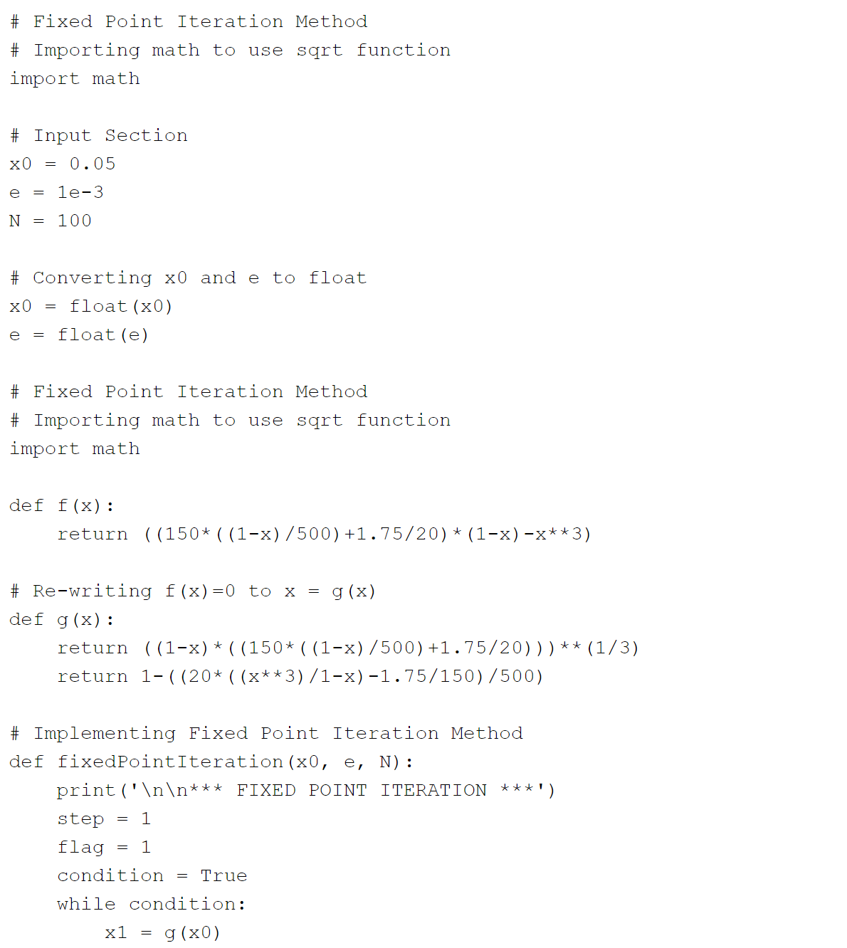

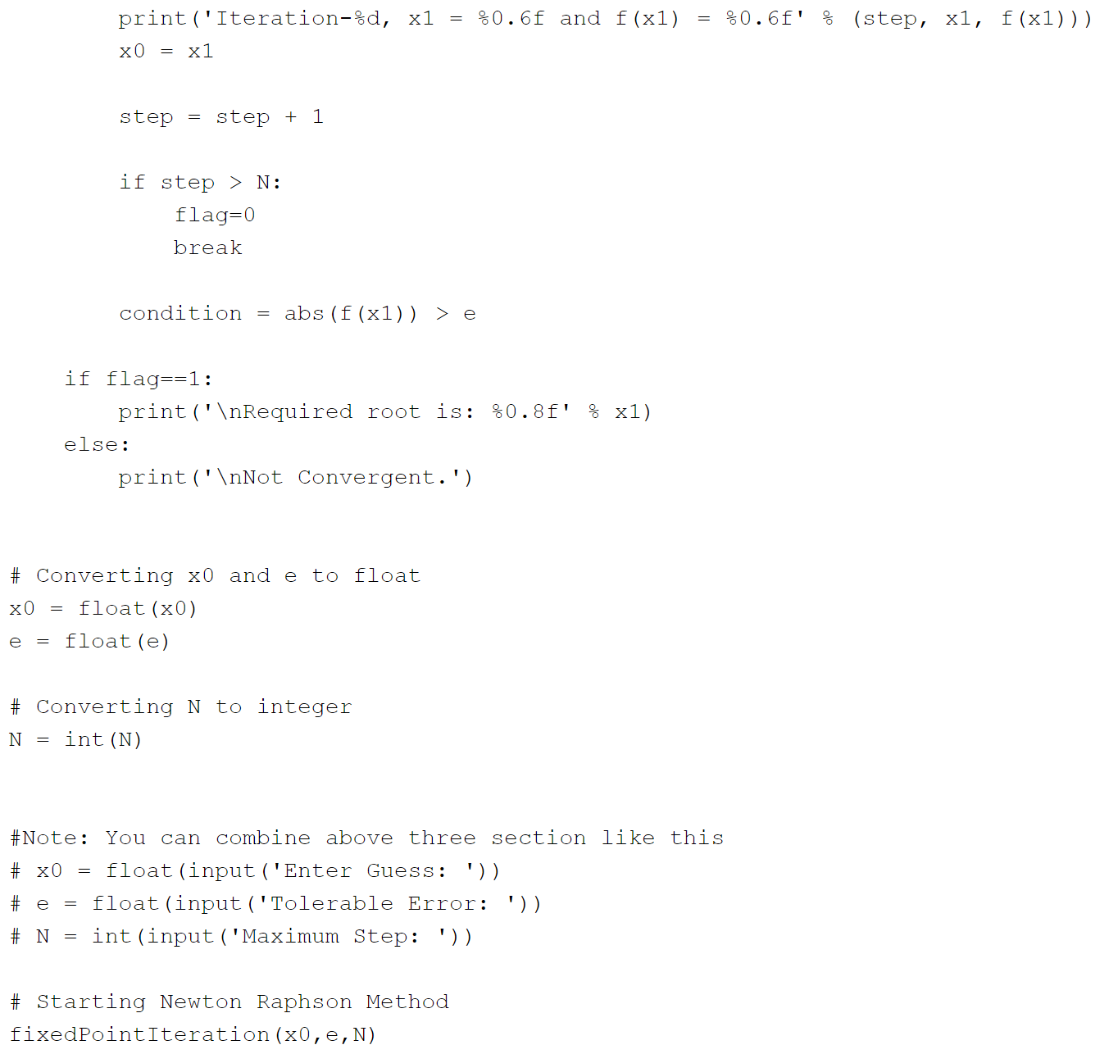

## Question 3

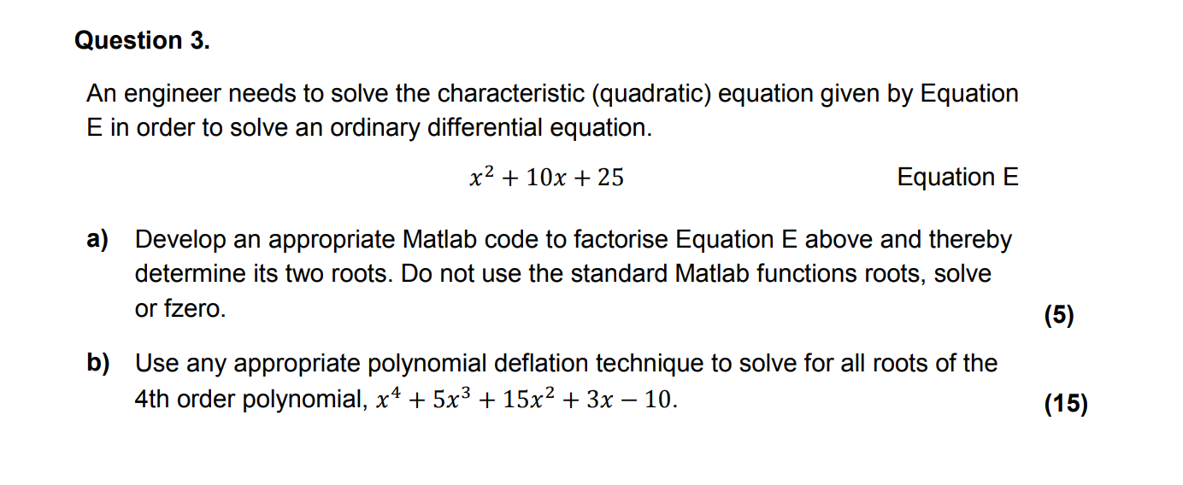

### Answer 3a)

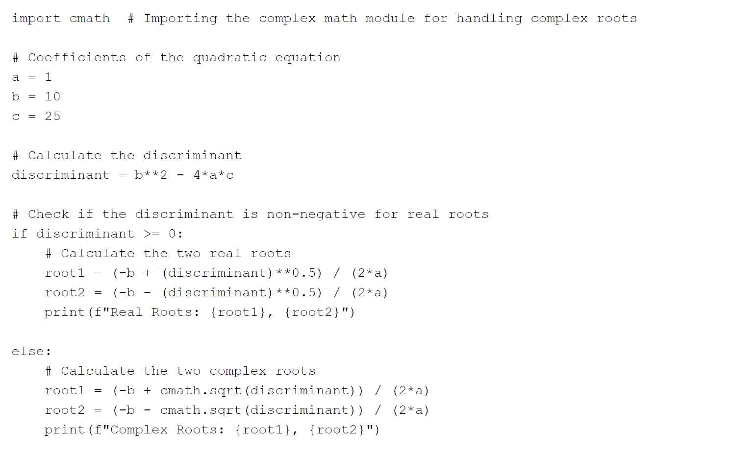

### Answer 3b)

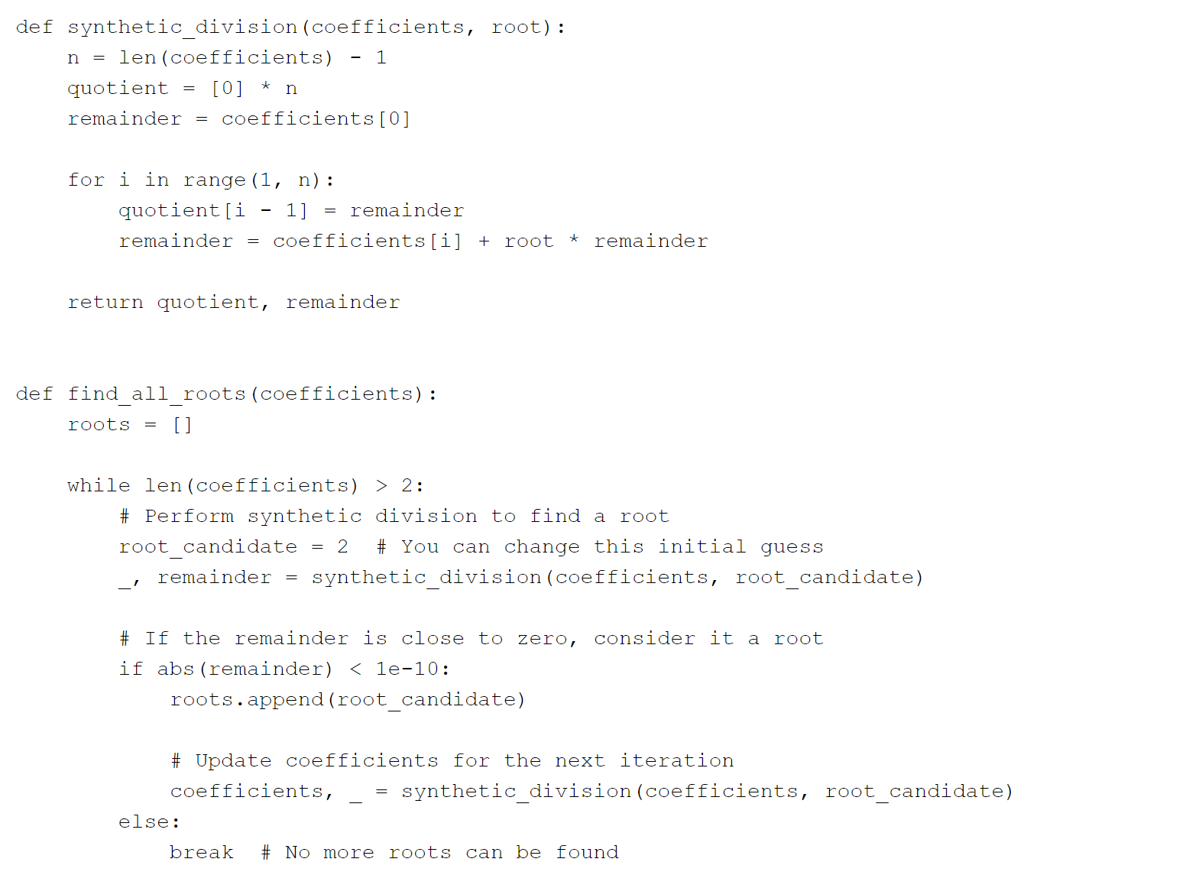

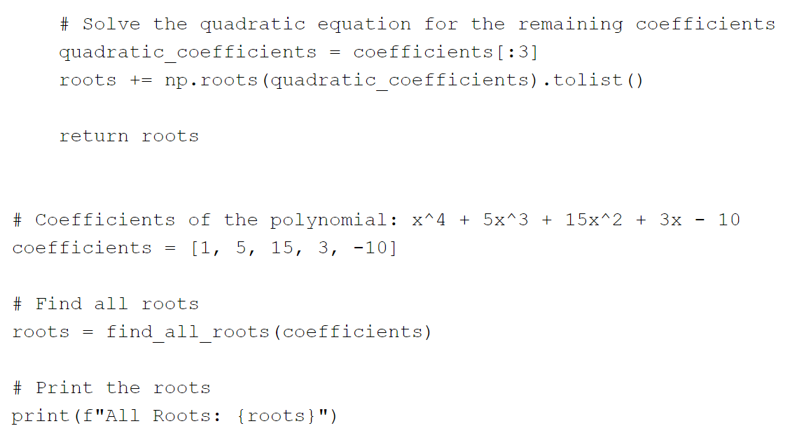

# 2019 Past Paper

## Question 1

See 2021 paper.

## Question 2

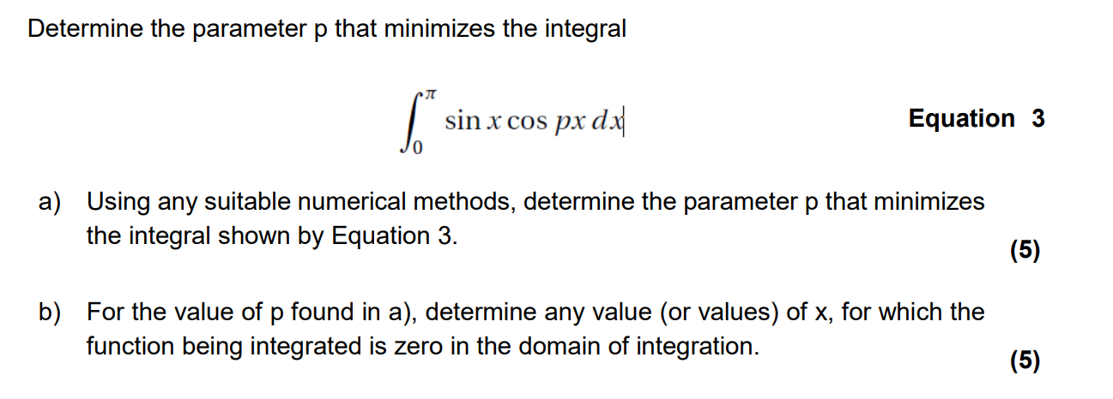

### Answer 2a)b)

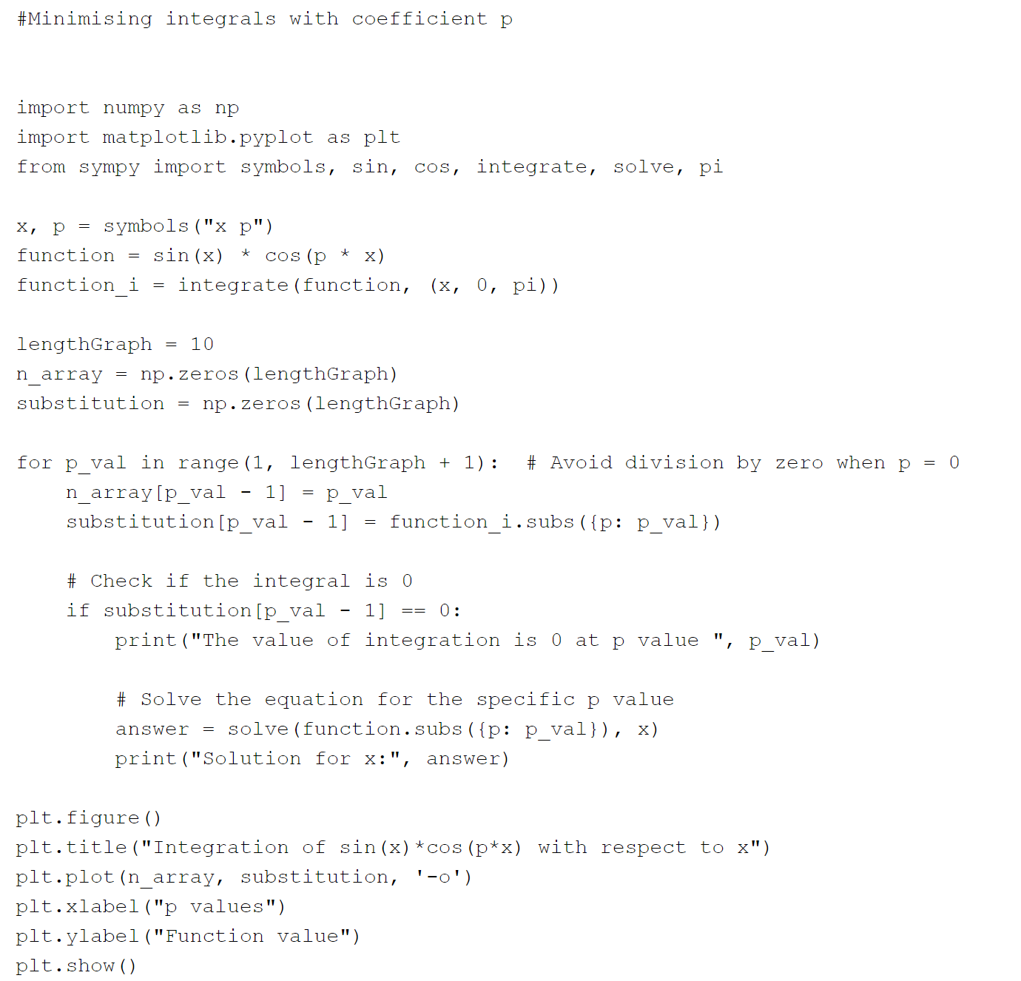

## Question 3

See 2021 Q2

## Question 4

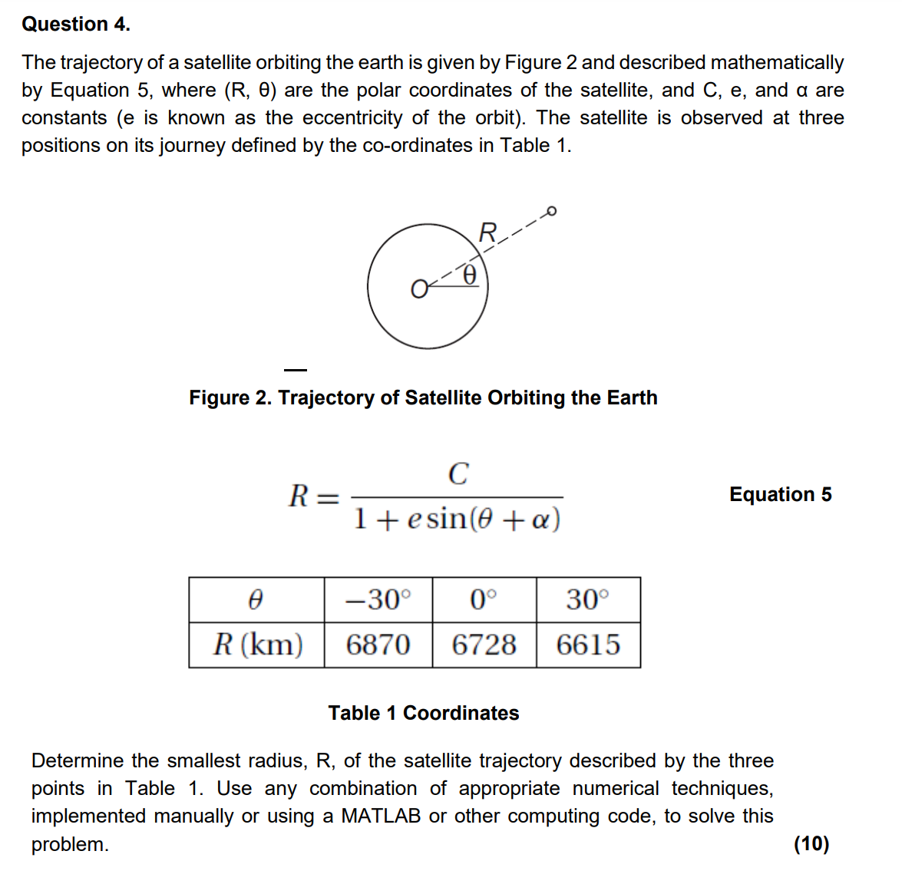

### Answer 4

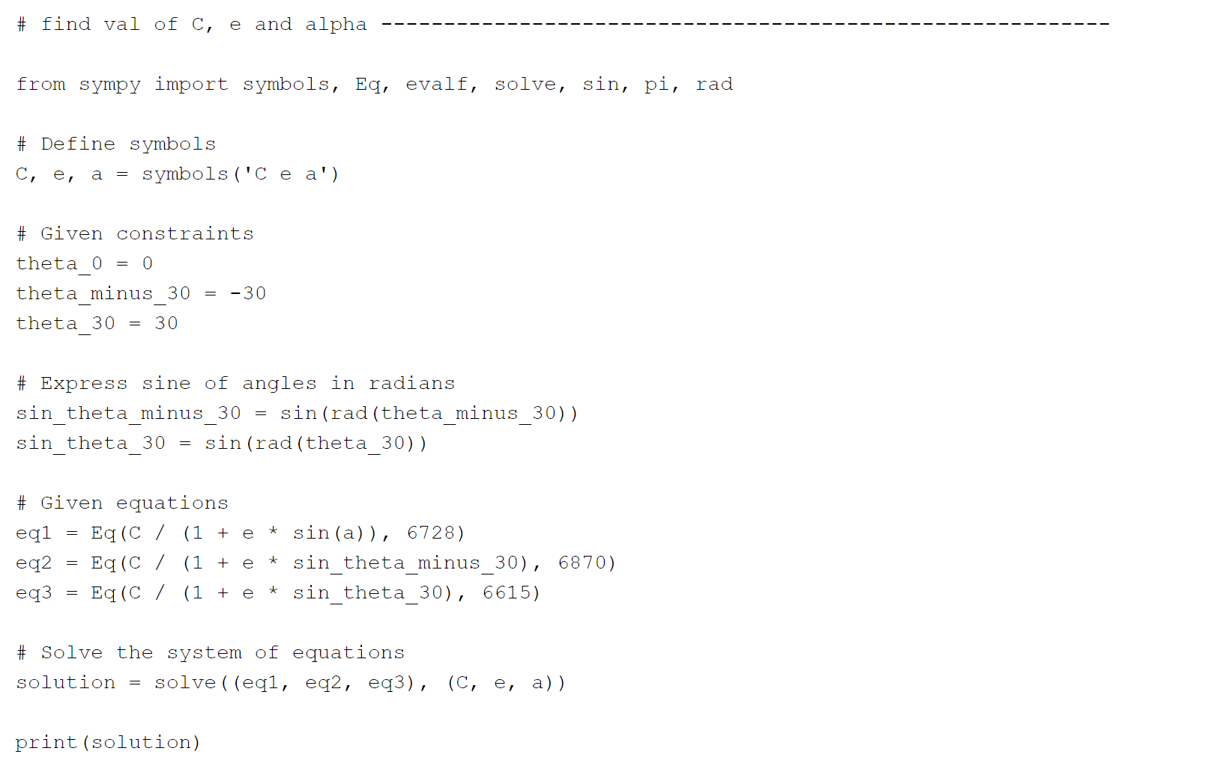_

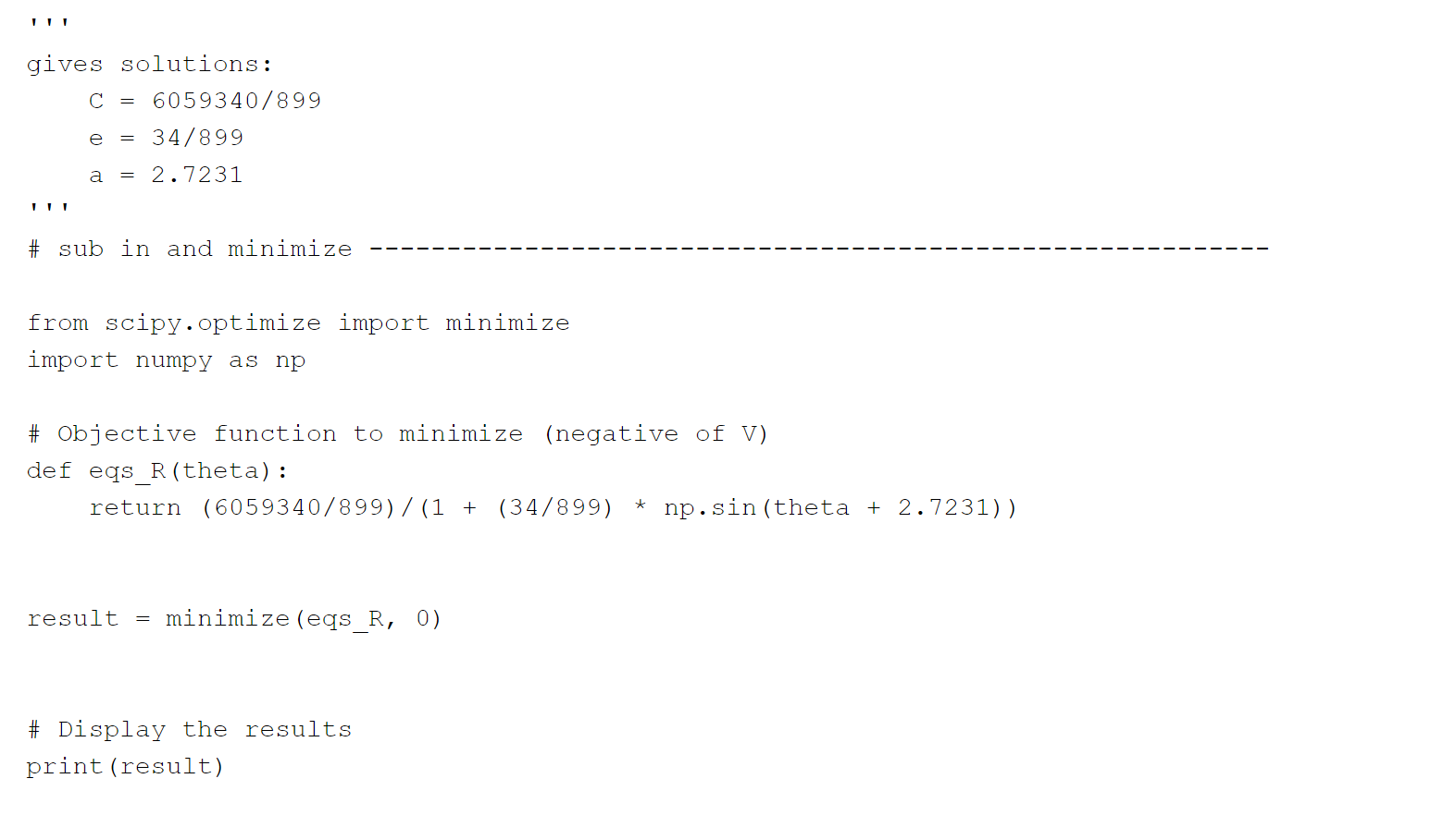

## Question 5

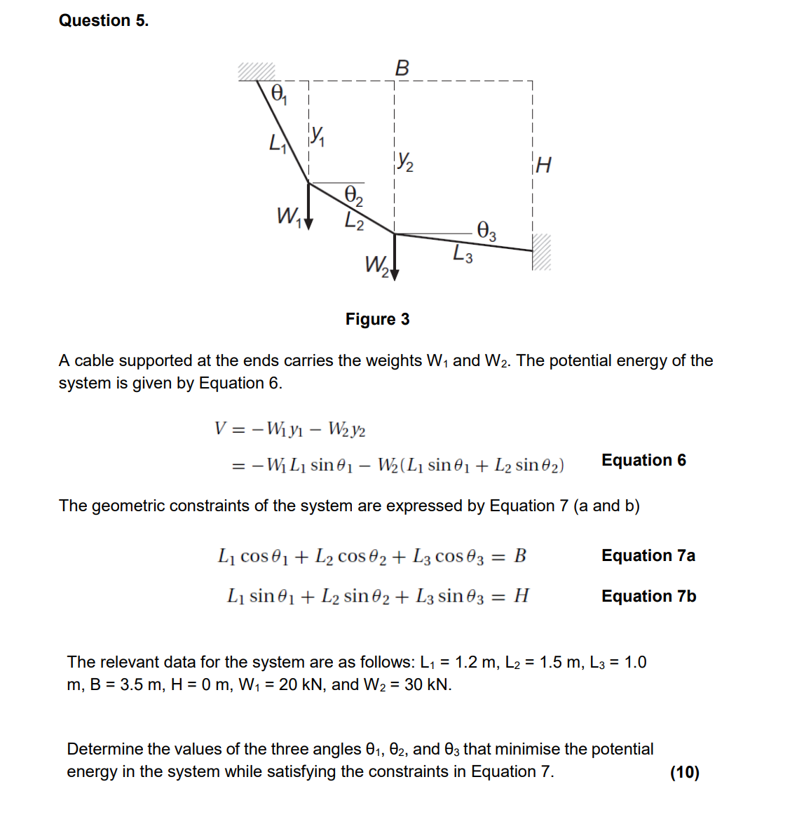

### Answer 5

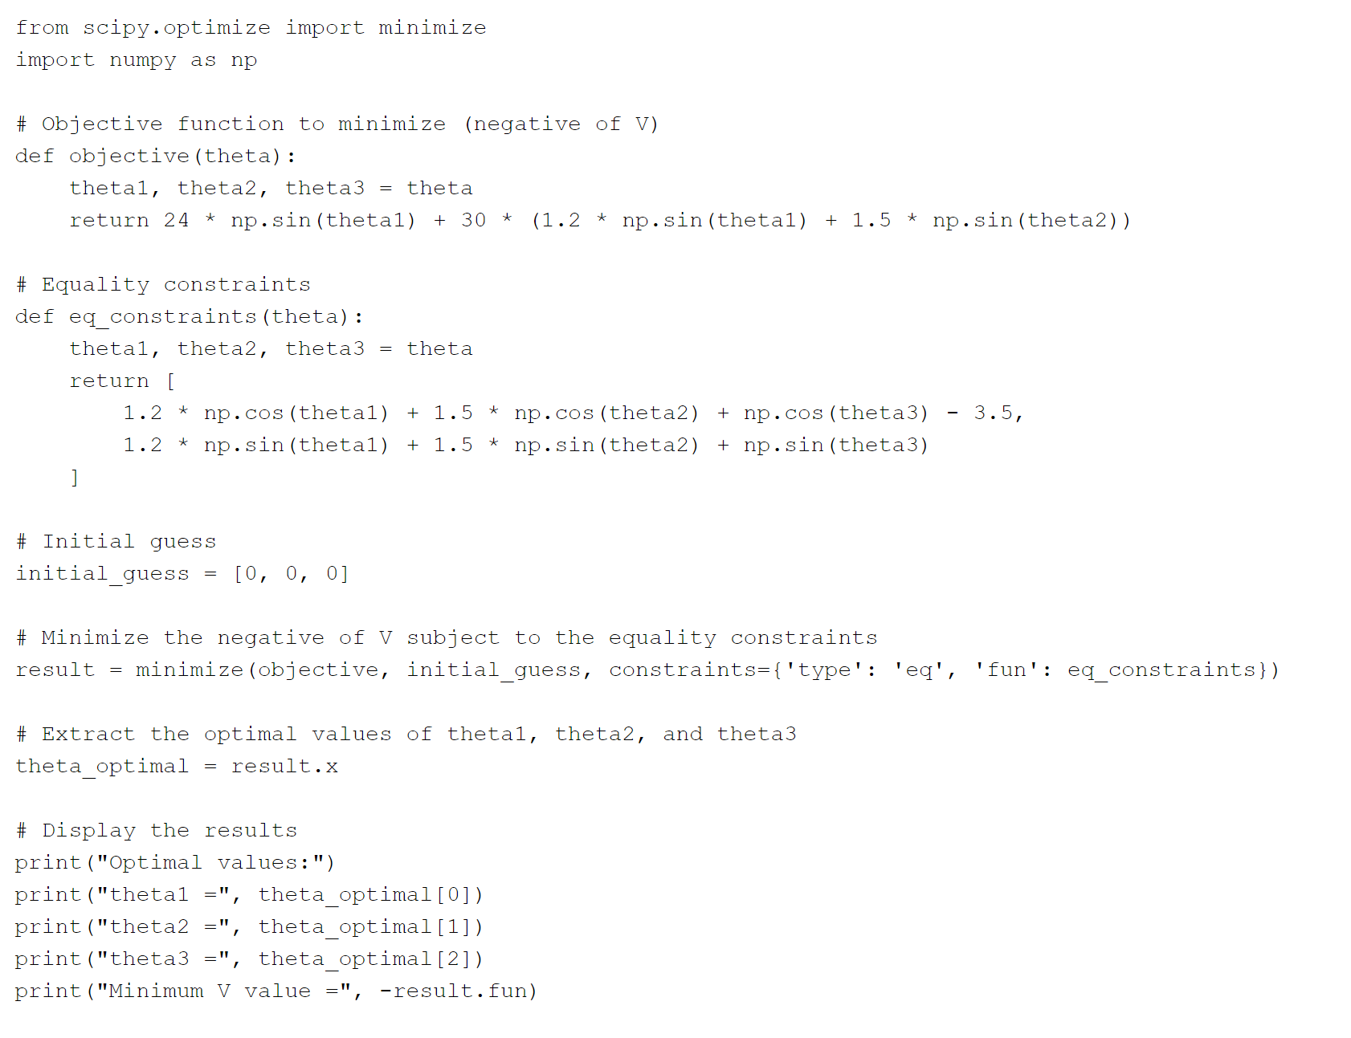

# 2020 Past Paper

## Question 1

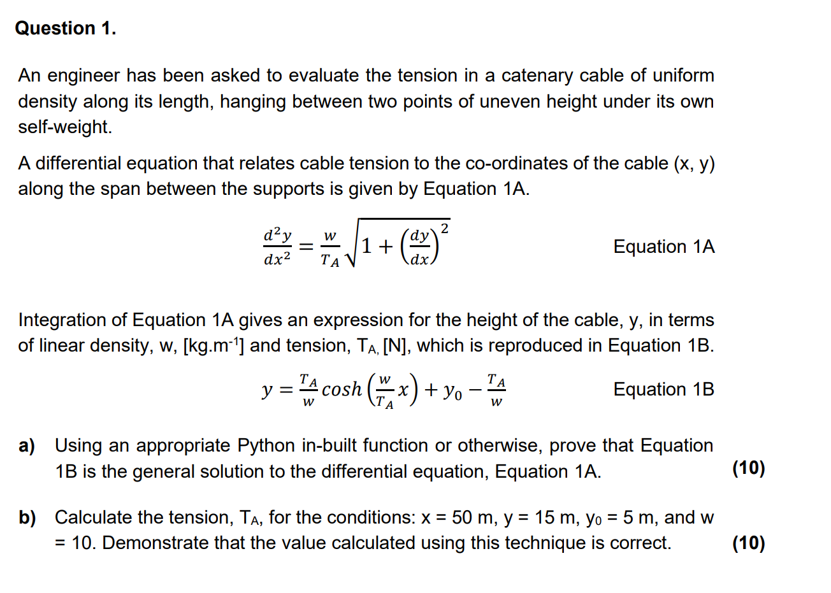

## Answer 1a)

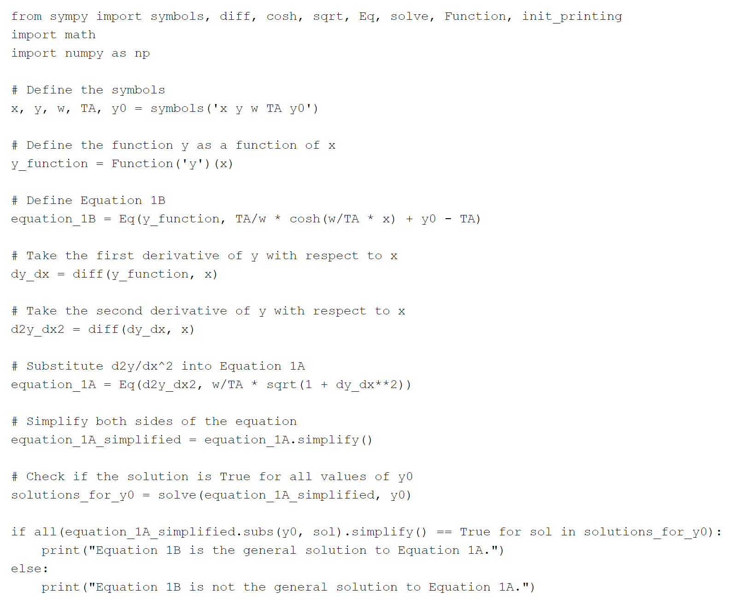

## Question 2

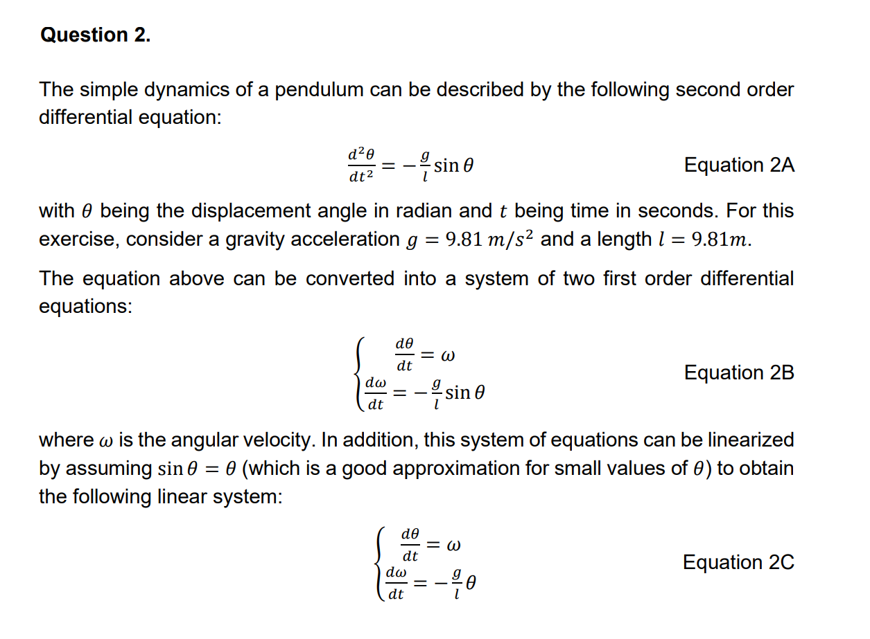

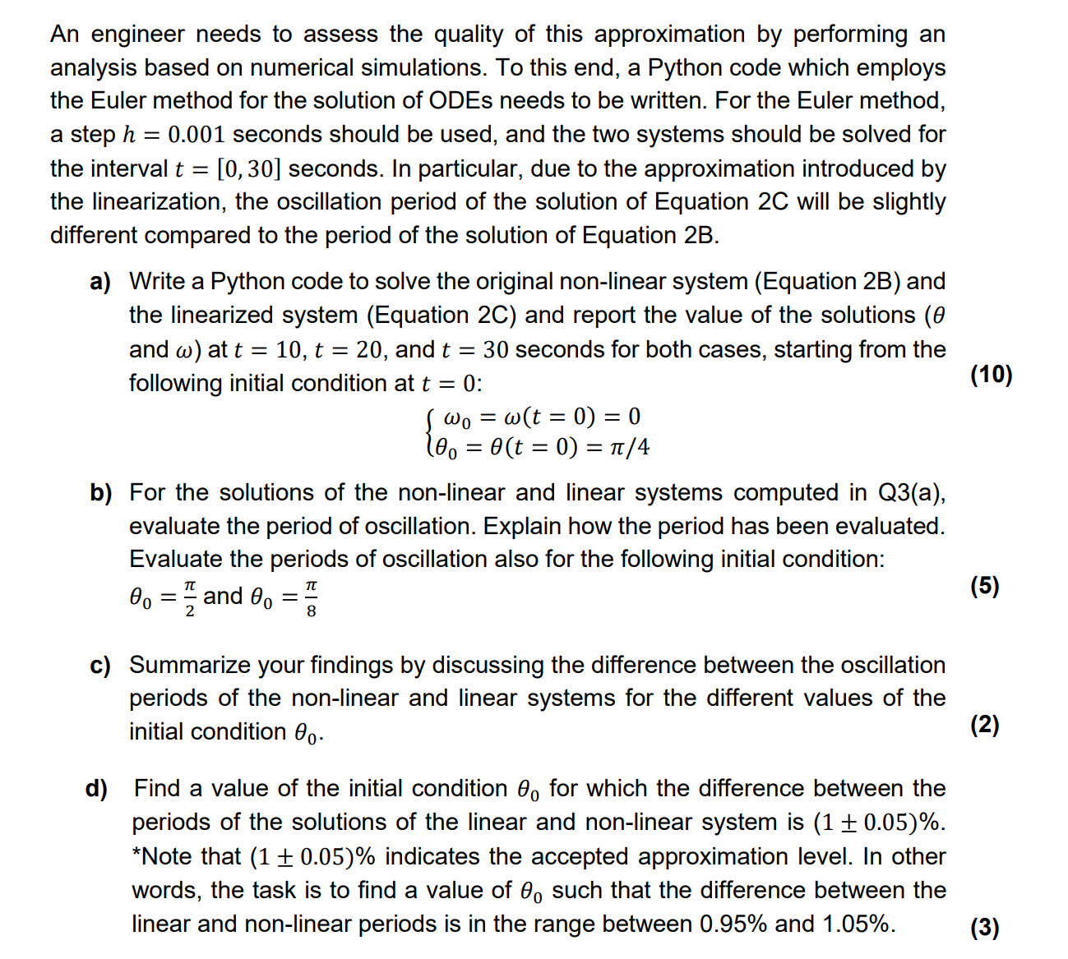

### Answer 2

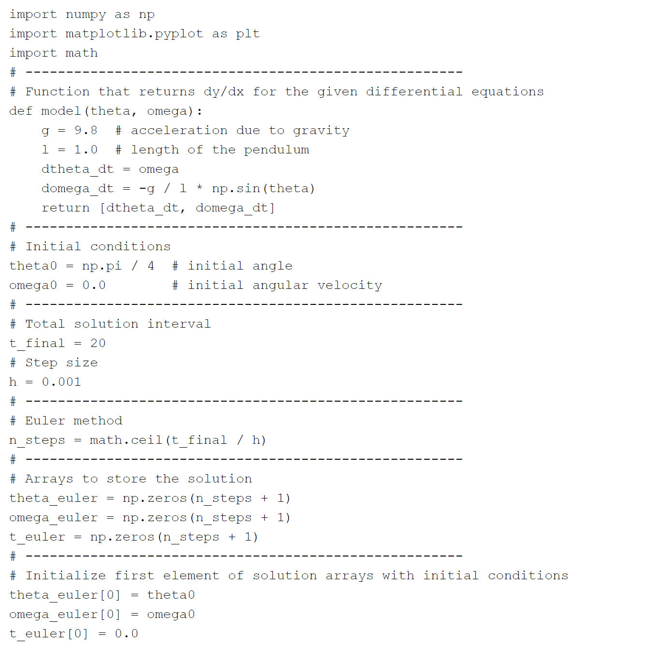

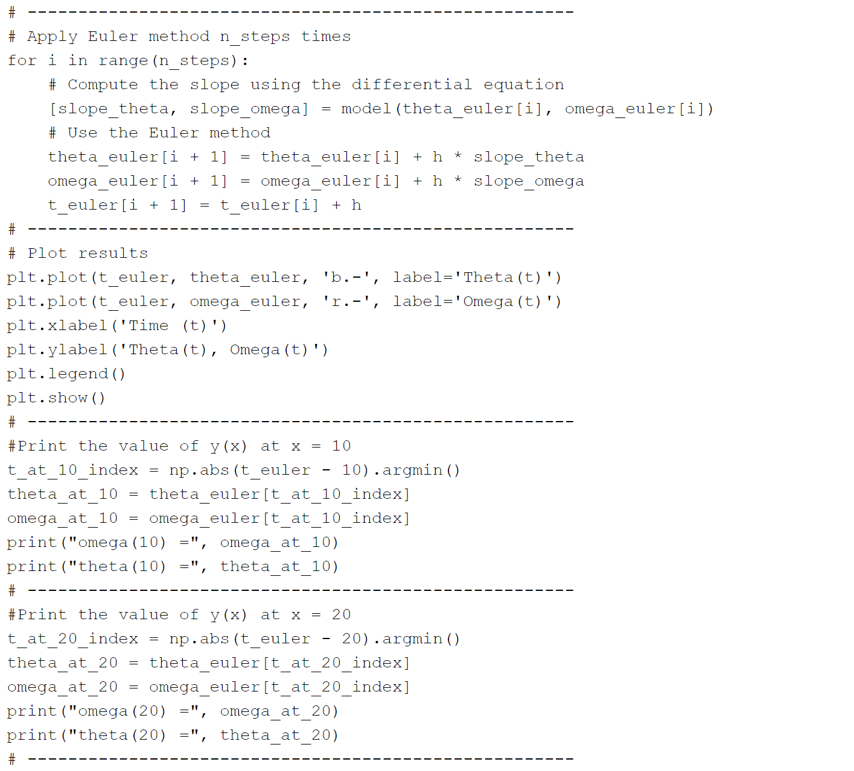

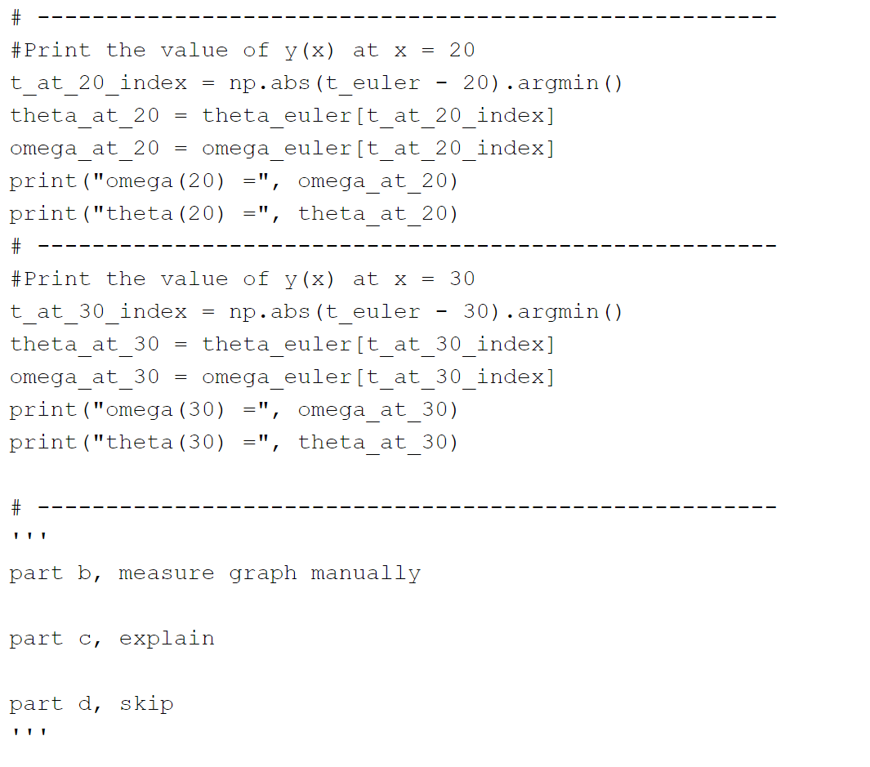

## Question 3

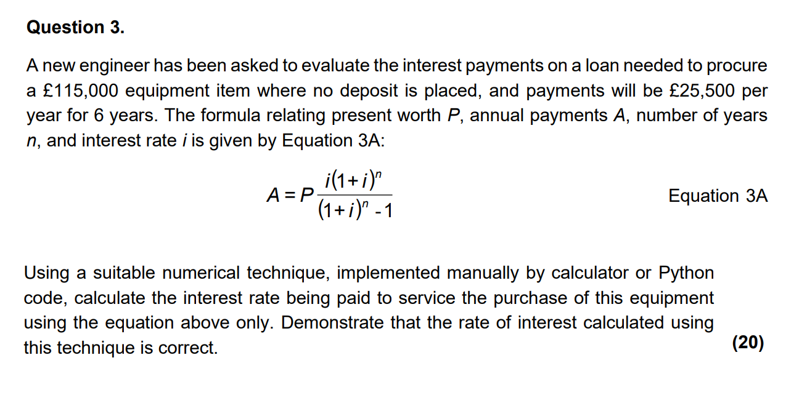

### Answer 3

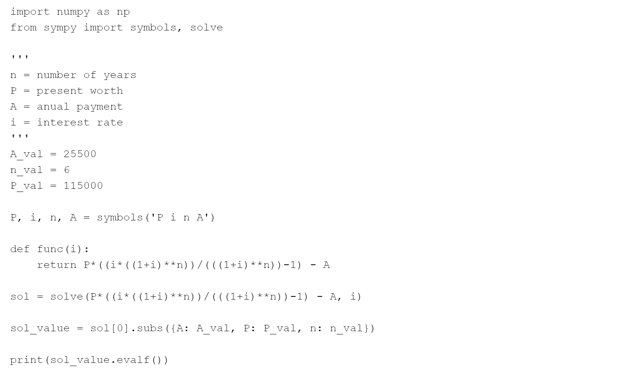

## Question 4

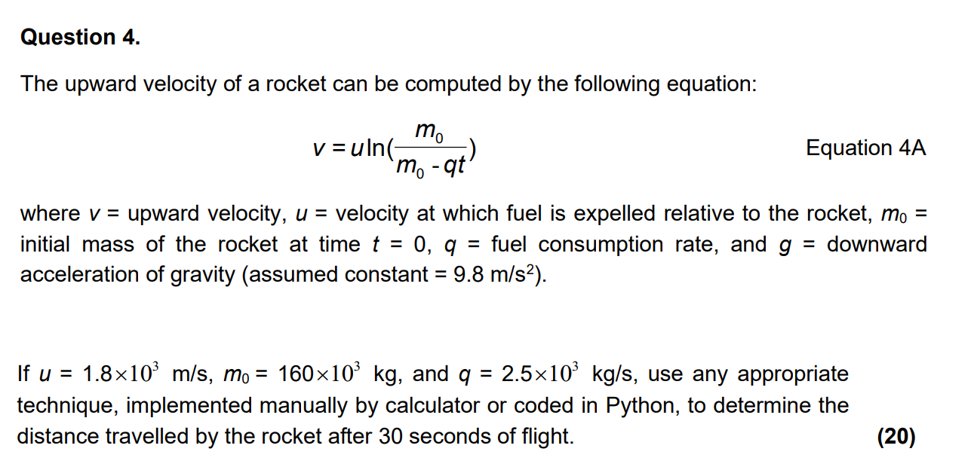

### Answer

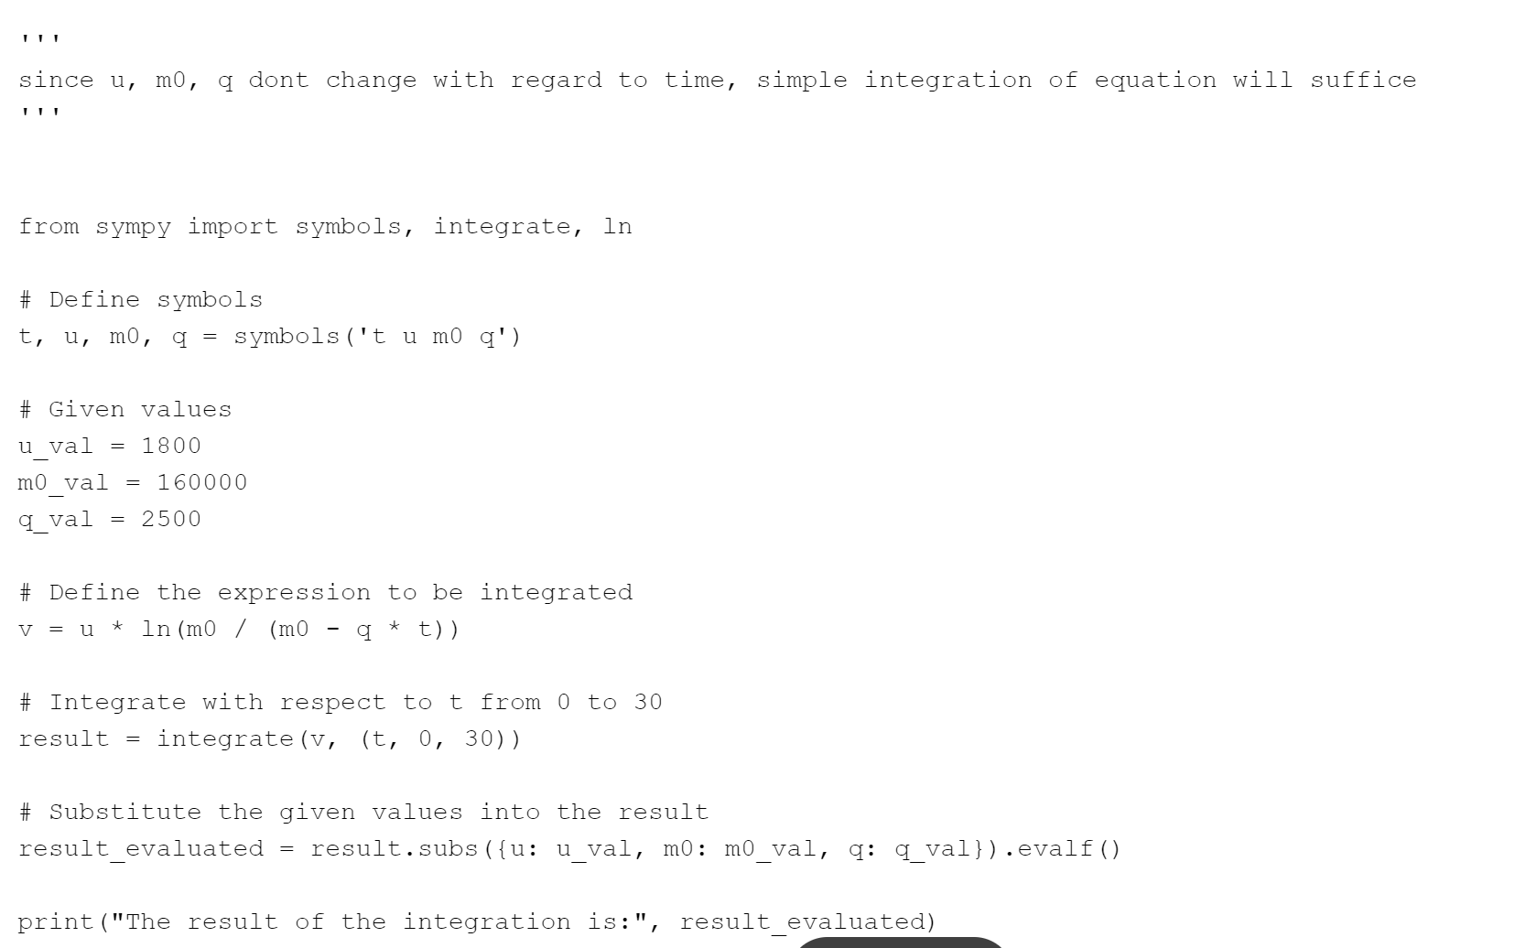

## Question 5

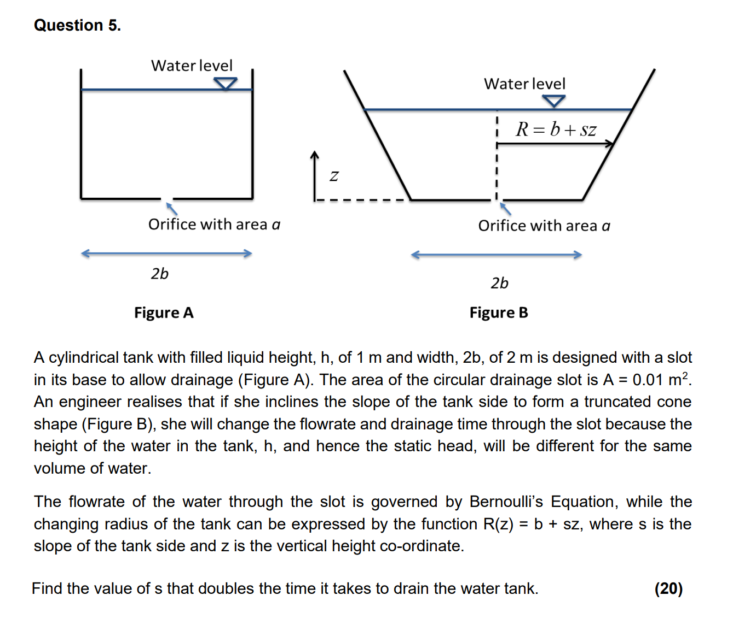

### Answer

*AHHH*

# 2021 Past Paper

## Q*uestion 1 (Same as 2019 Question 1)

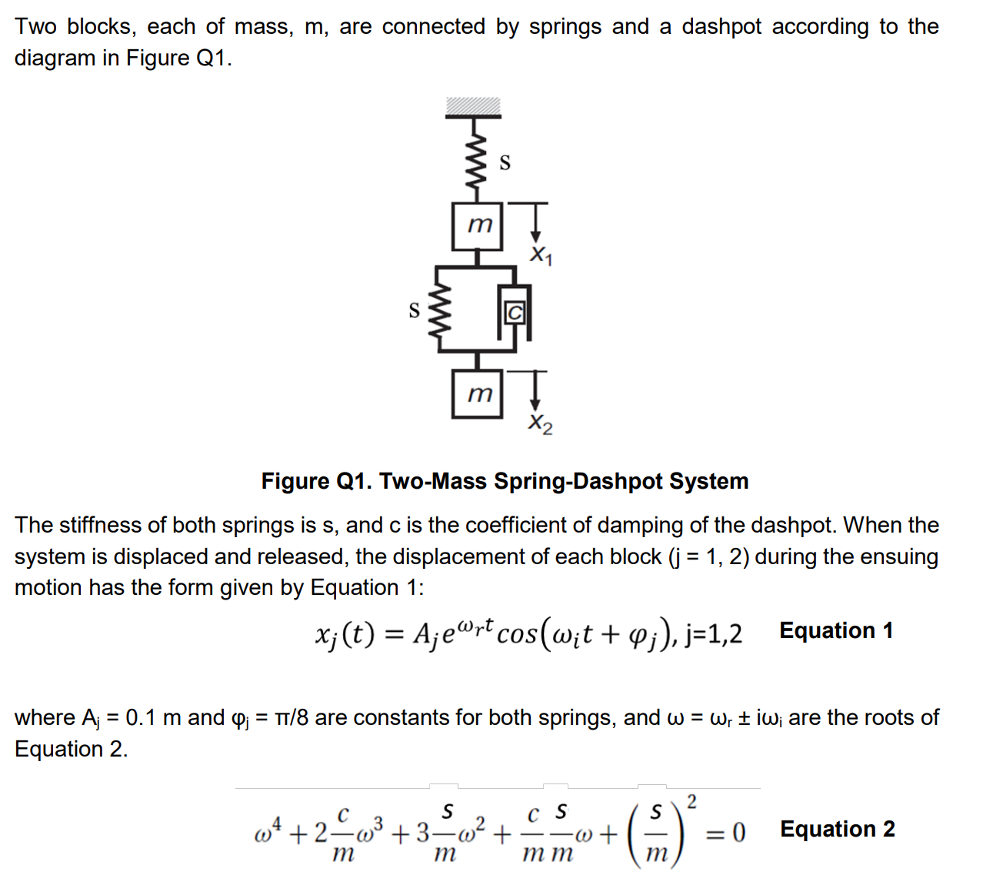

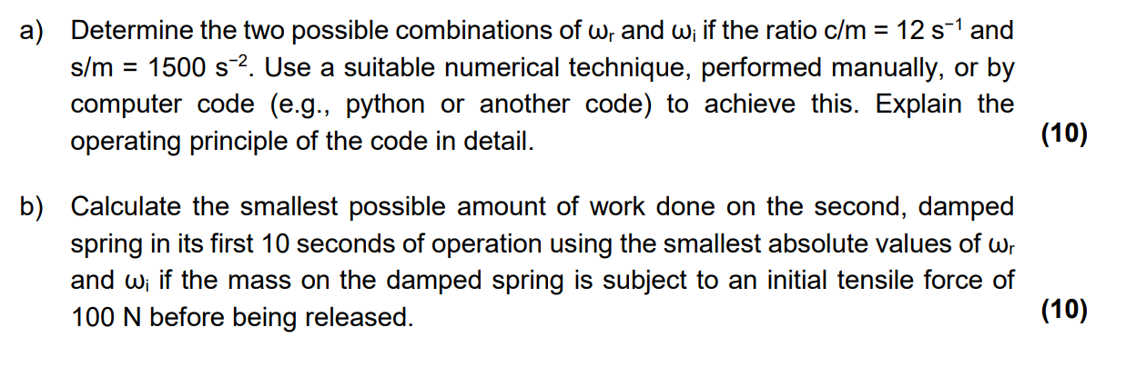

### Answer 1a)

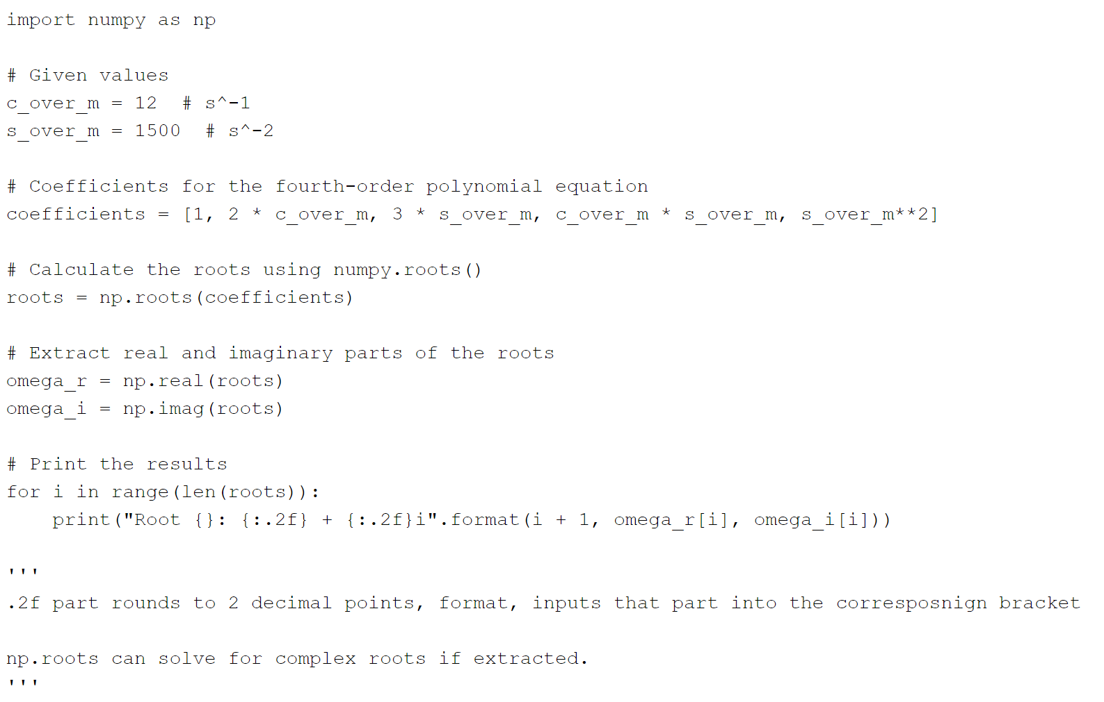

### Answer 1b)

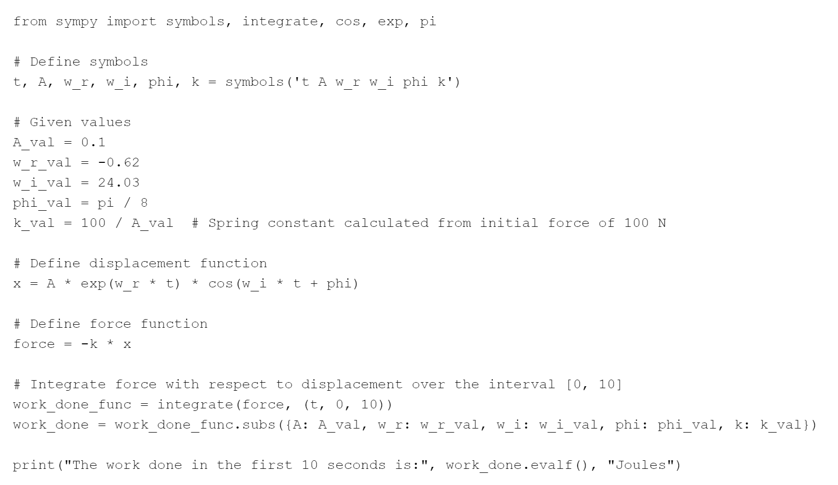

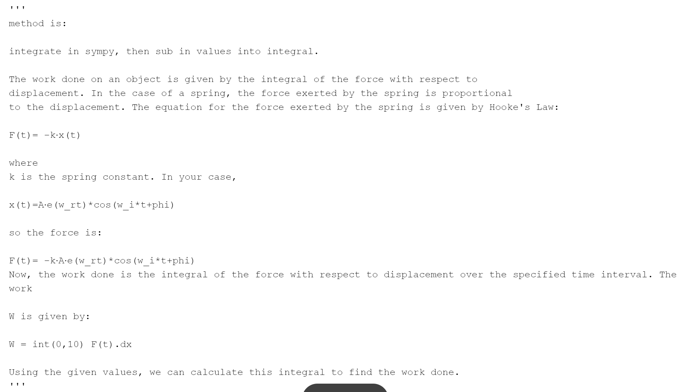

## Question 2 (Same as 2019 Question 3)

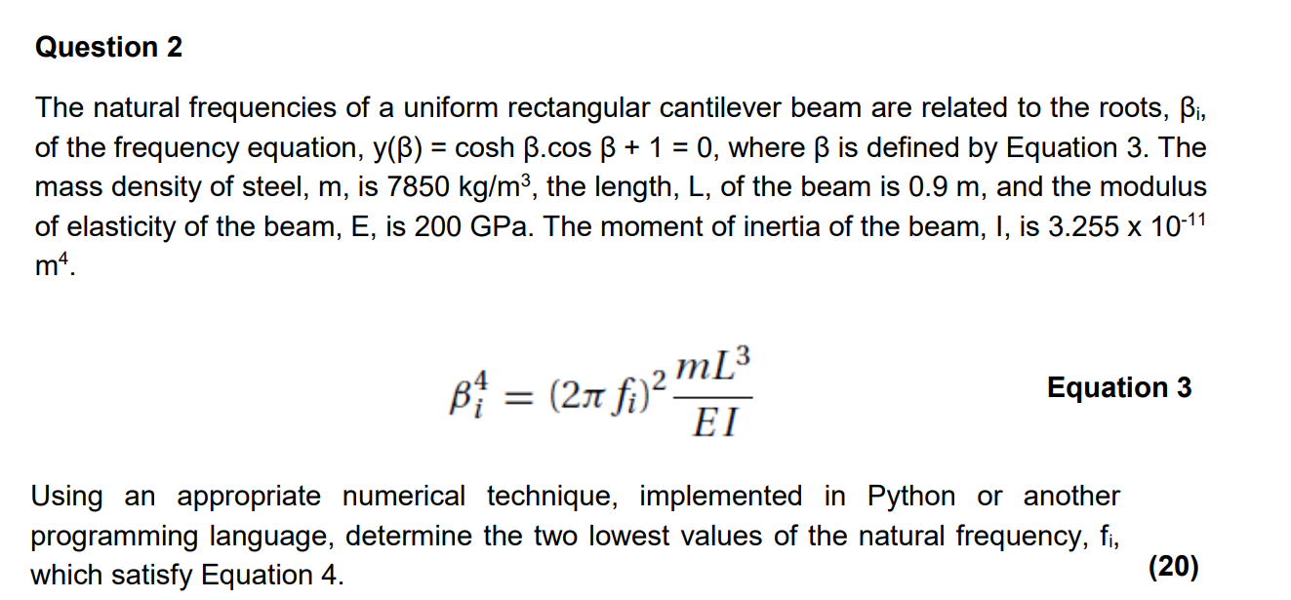

### Answer 2

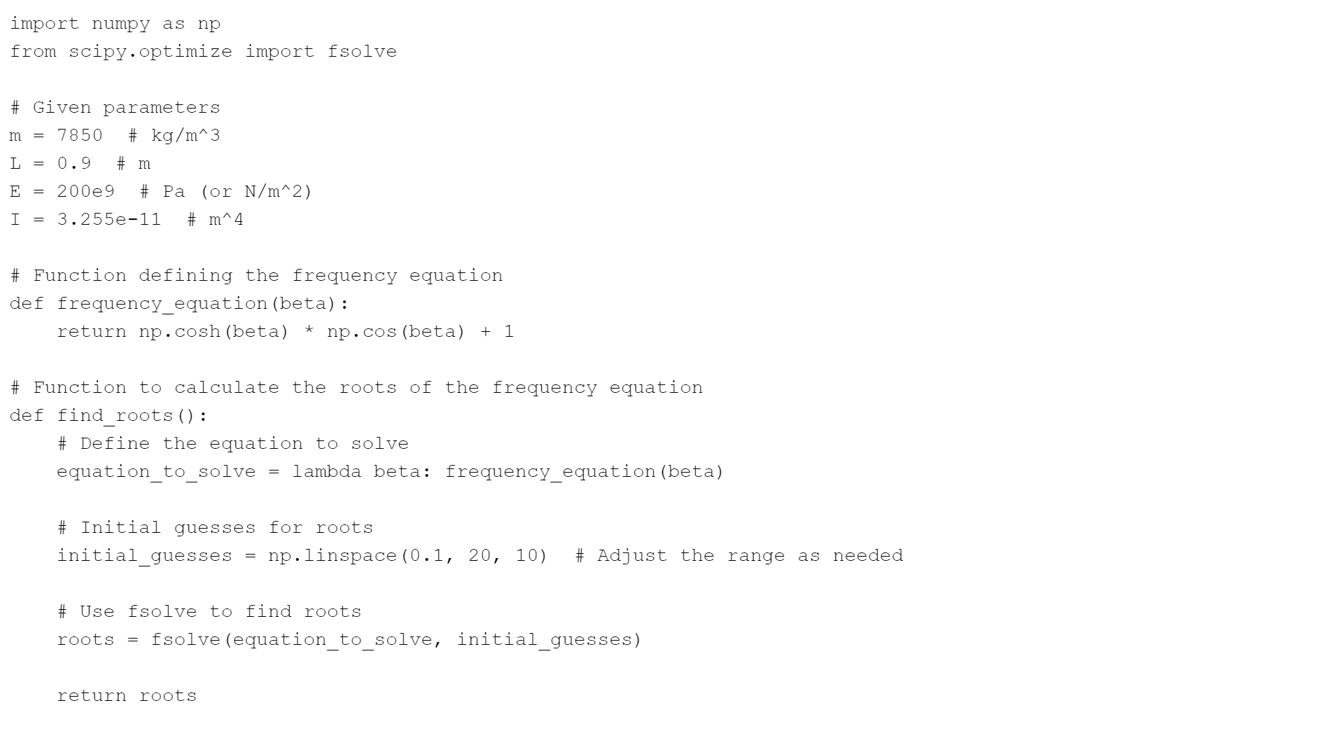

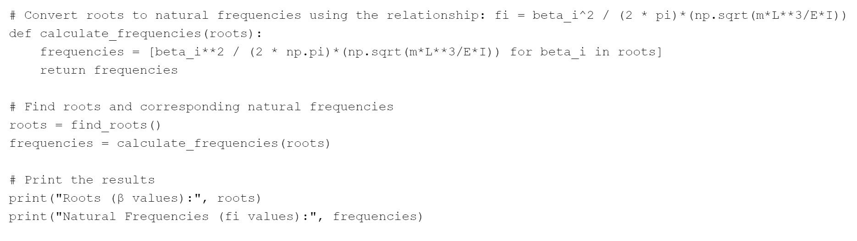

## Question 3

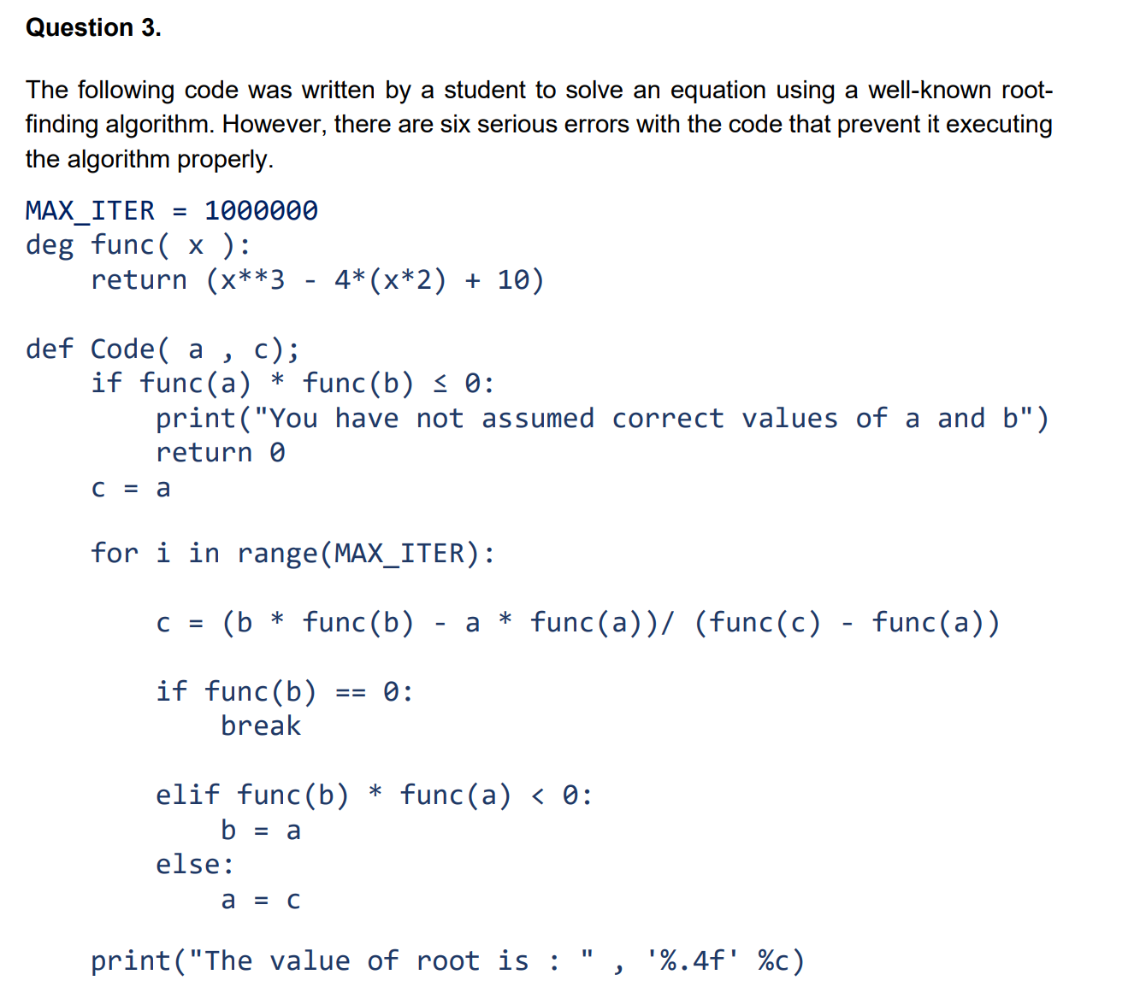

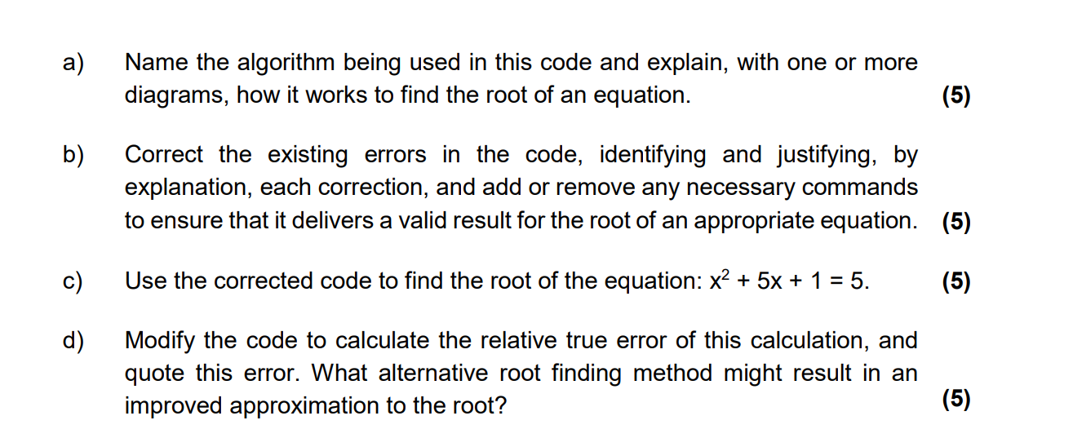

### Answer 3a)

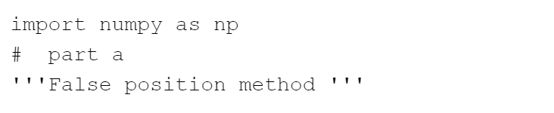

### Answer 3b)

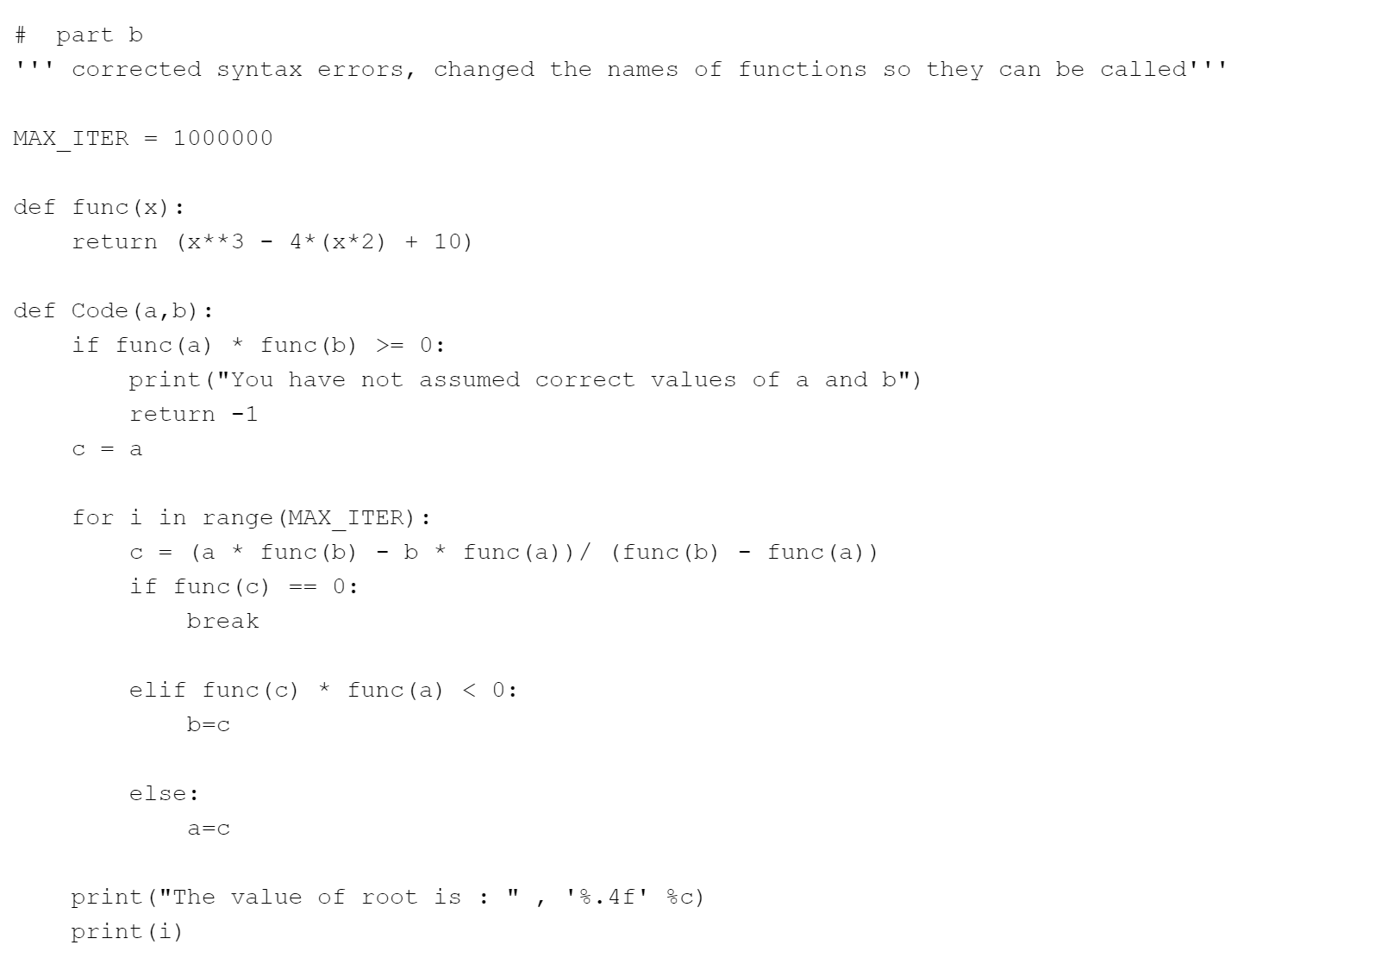

### Answer 3c)

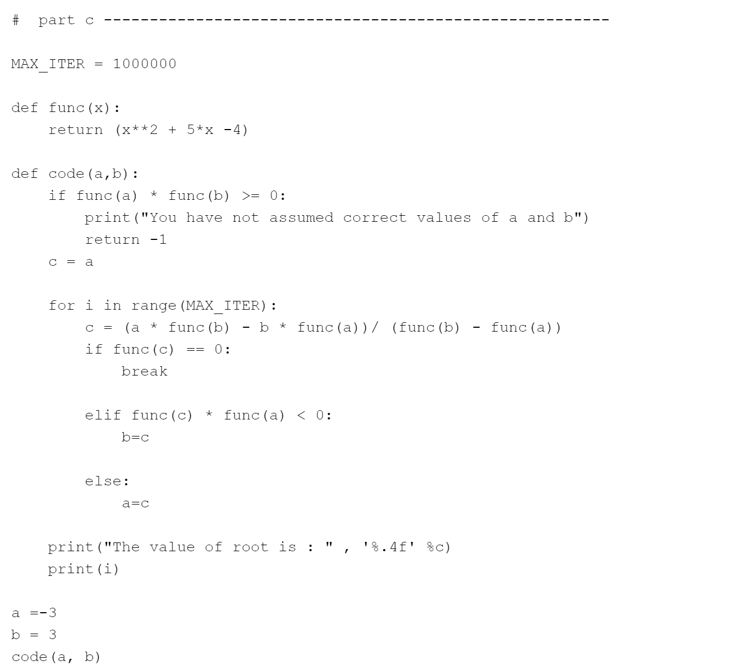

### Answer 3d)

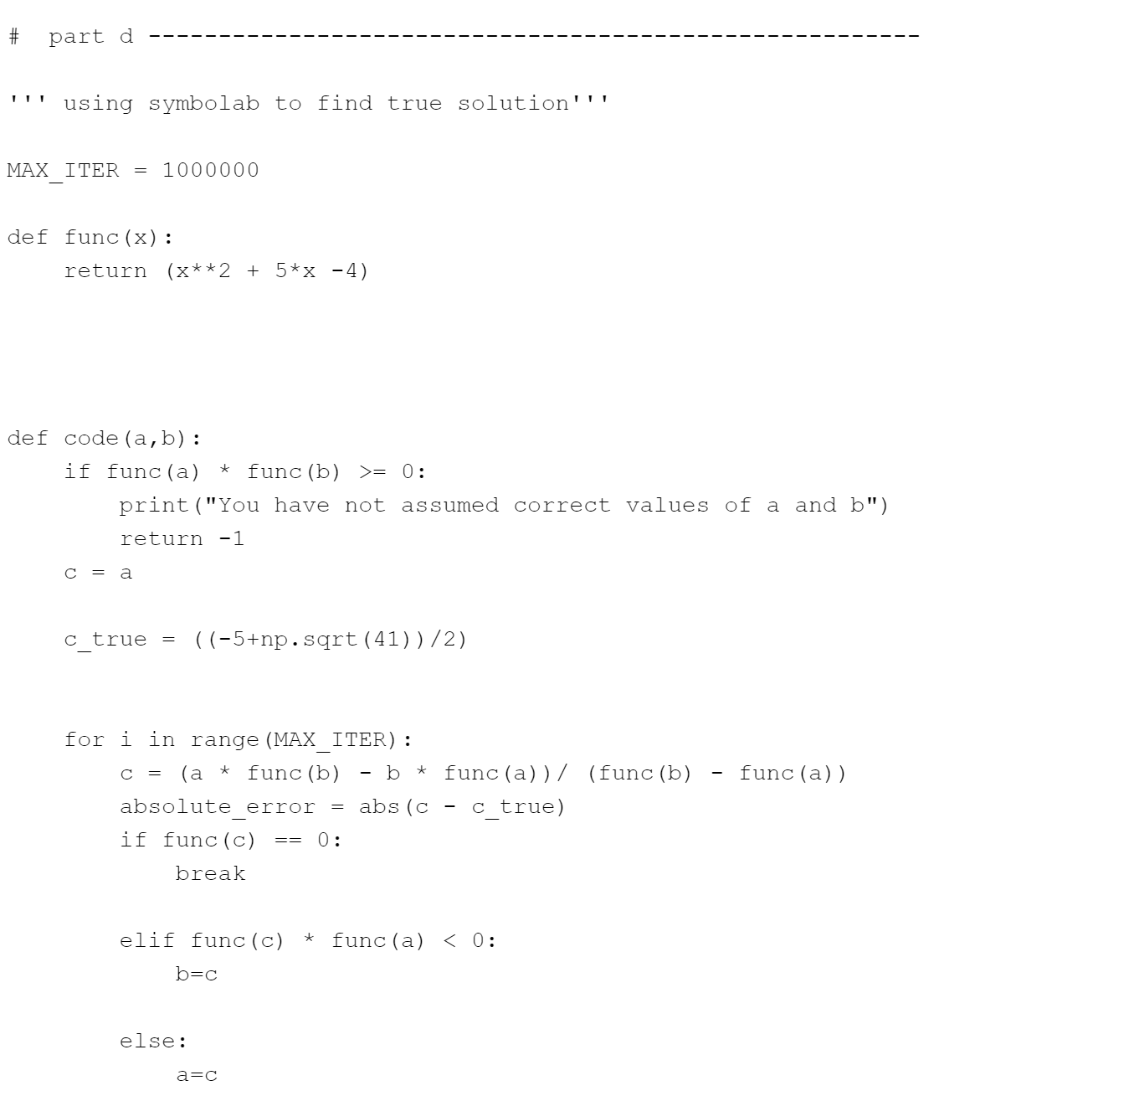

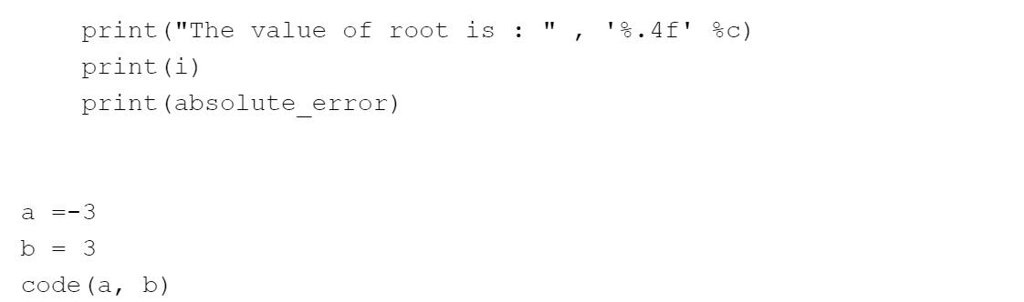

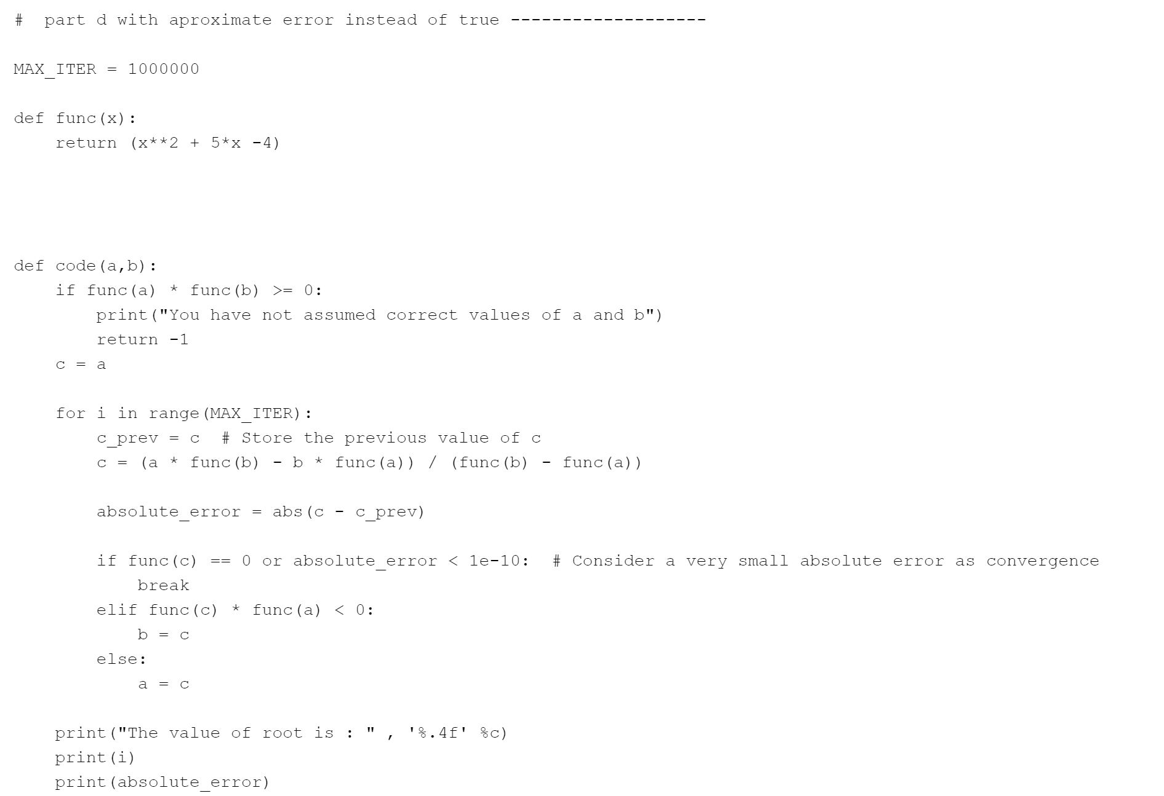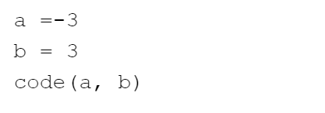

## Question 4

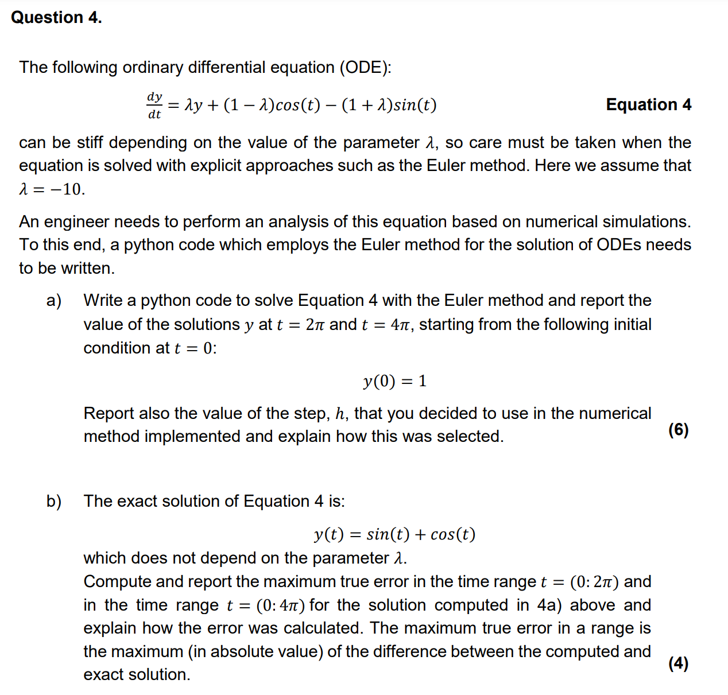

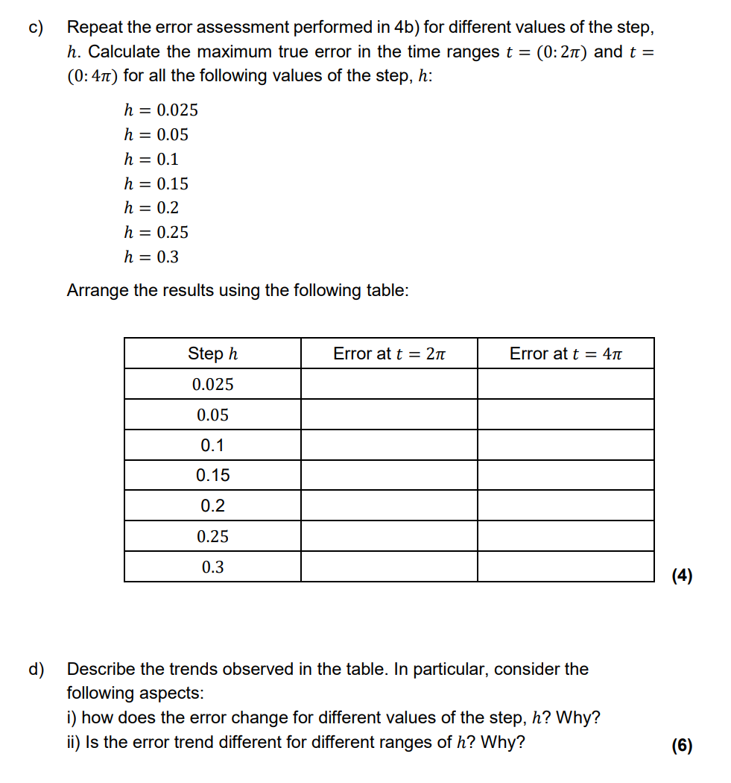

### Answer 4a)

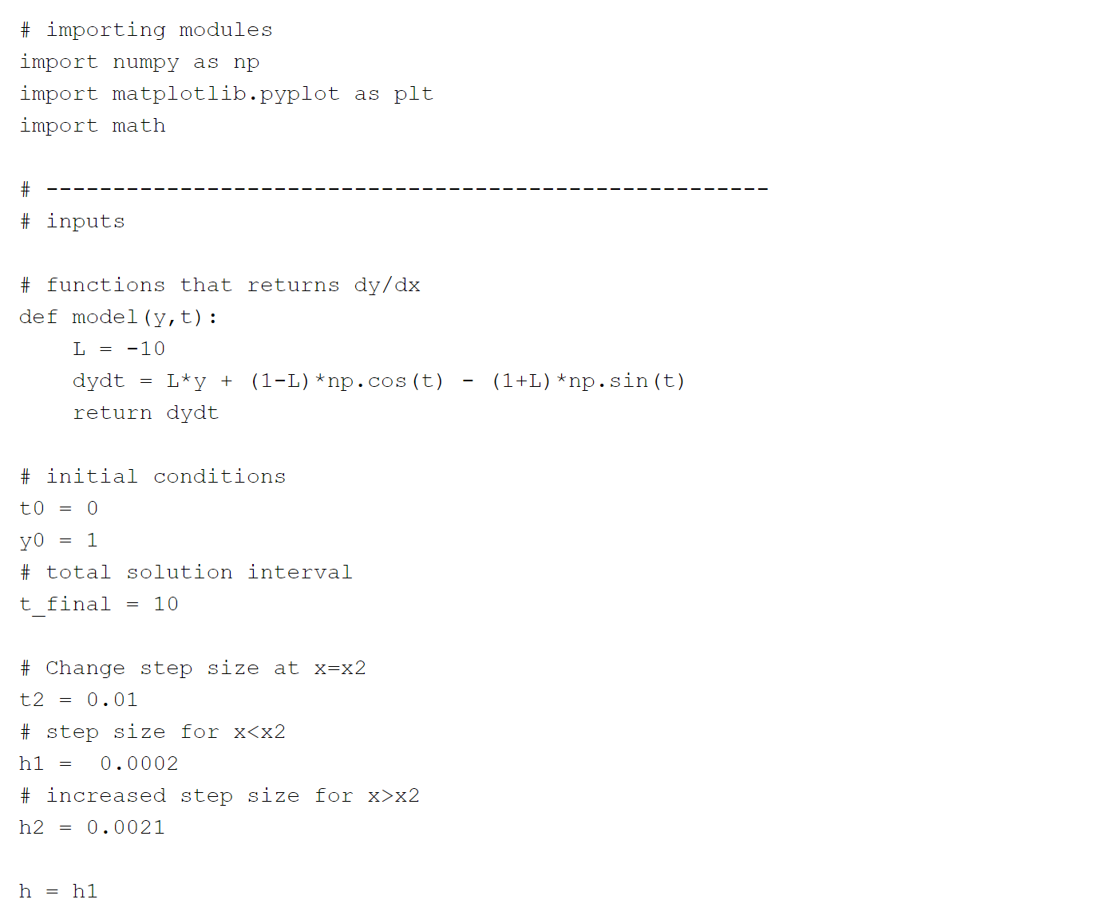

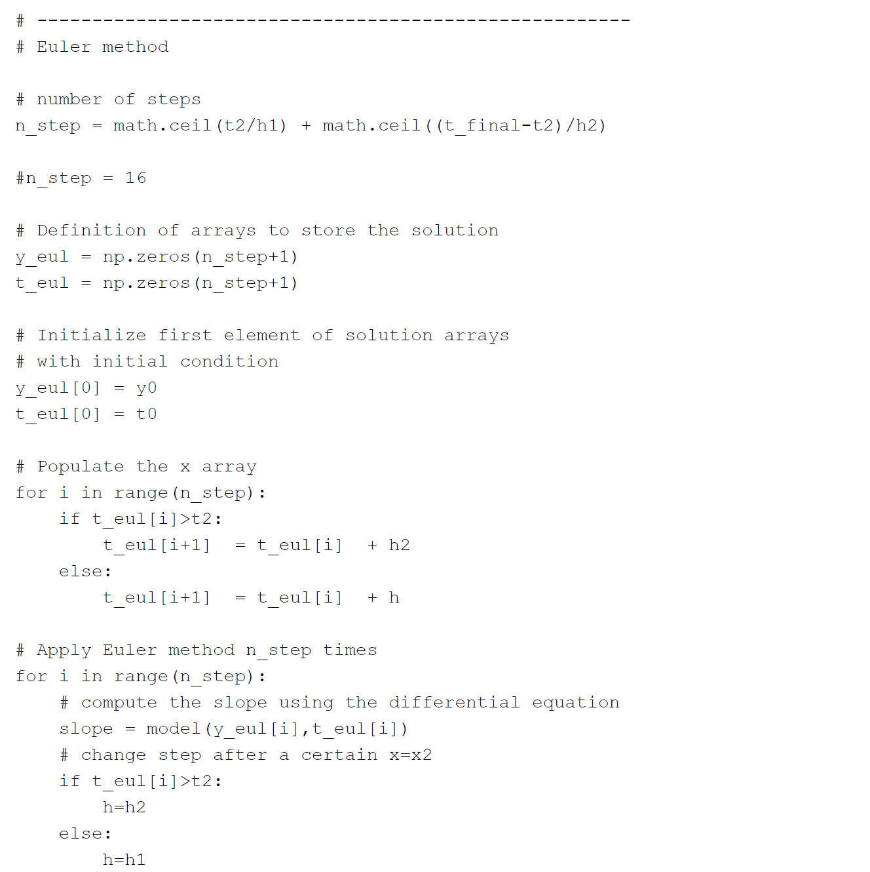

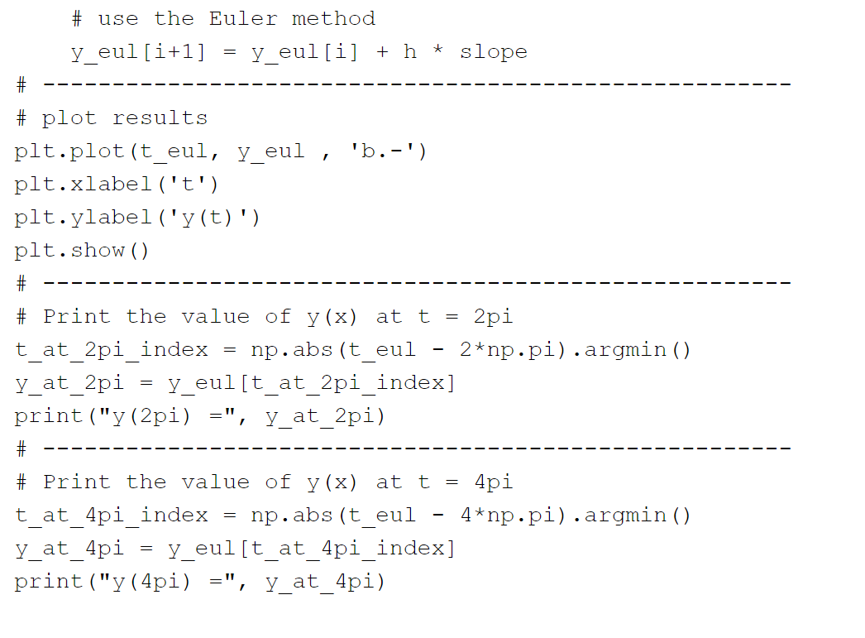

### Answer 4b)

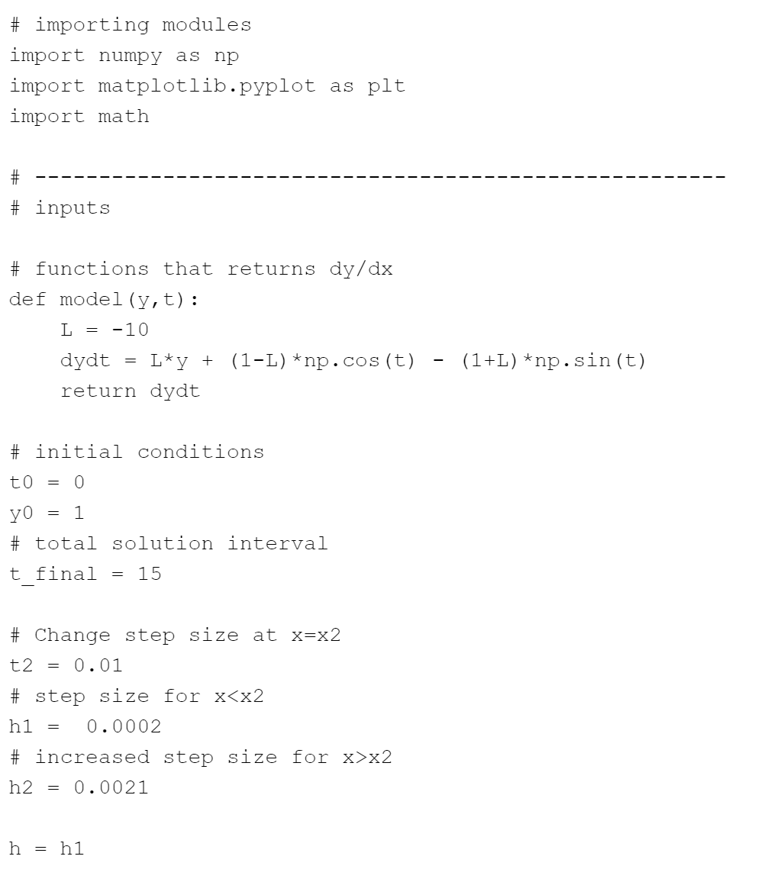

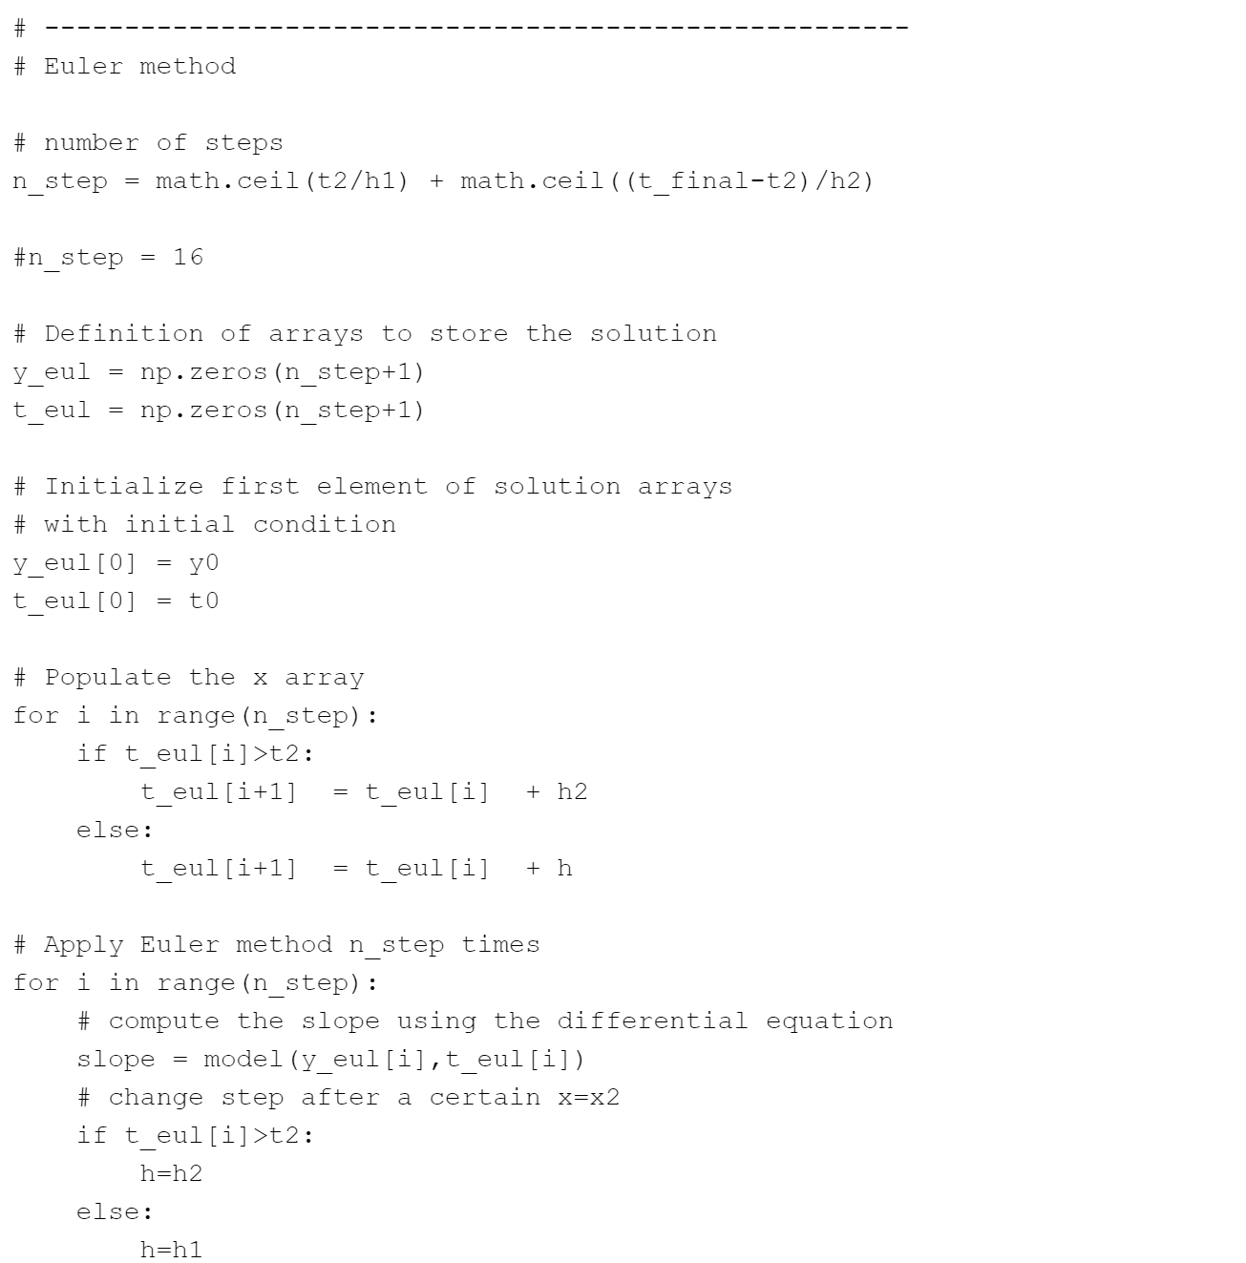

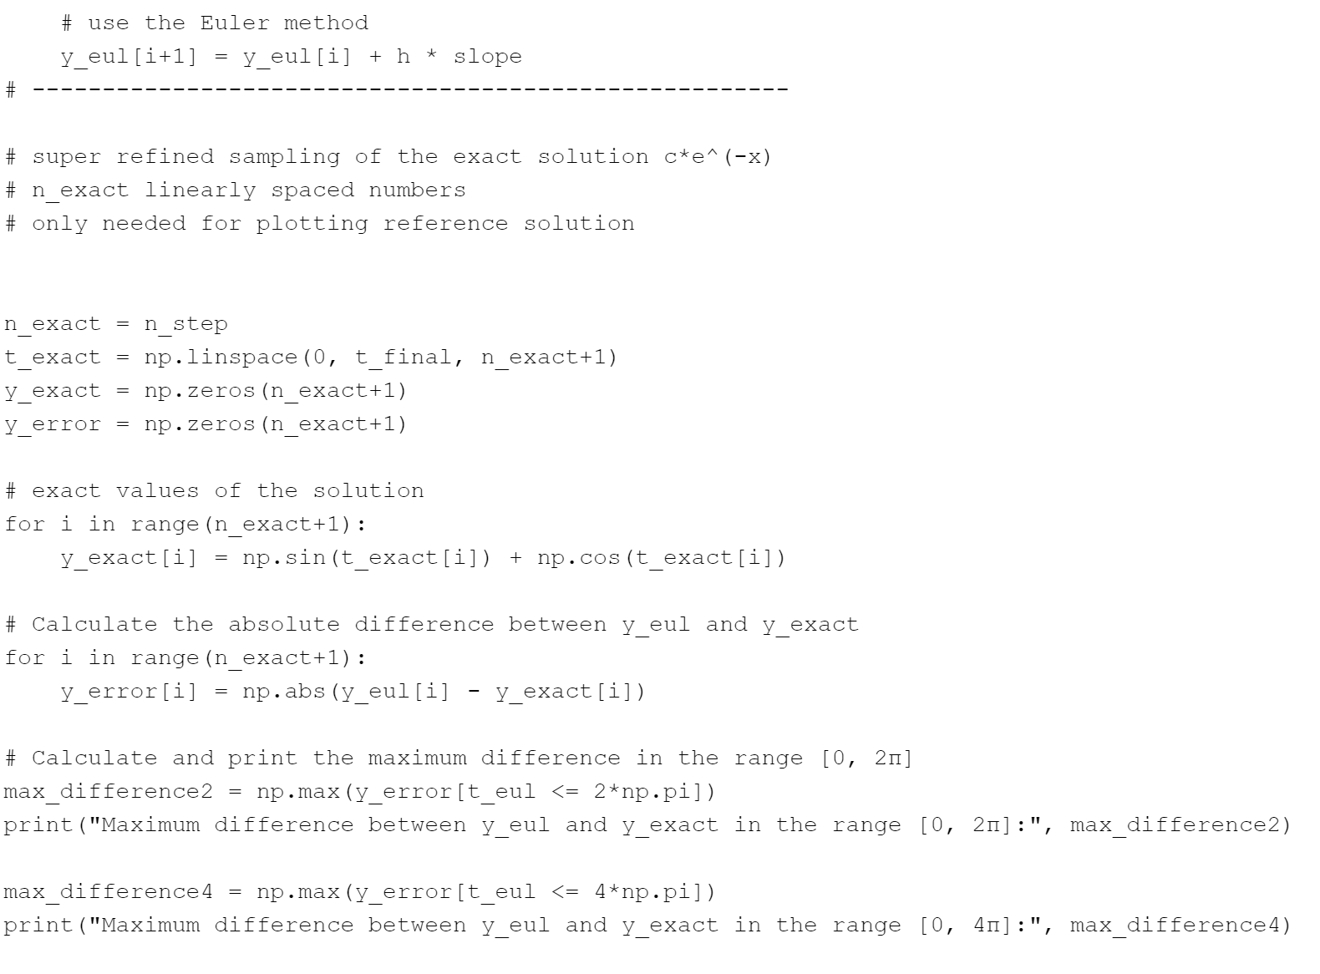

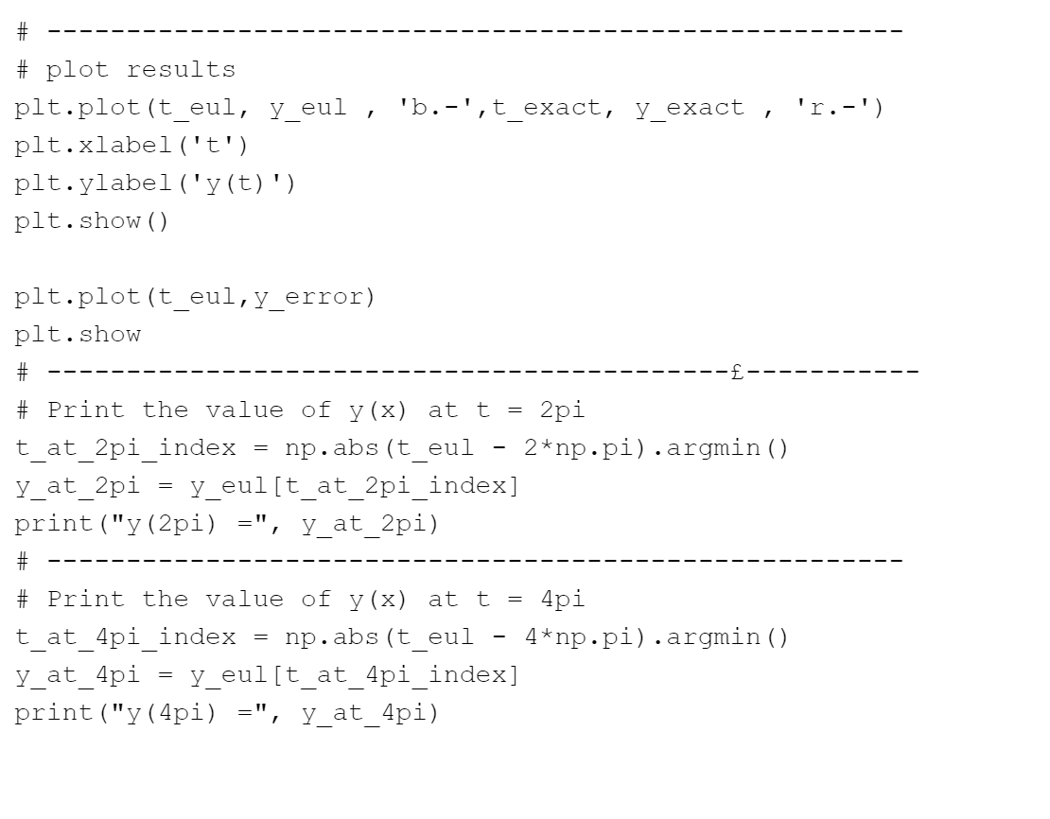

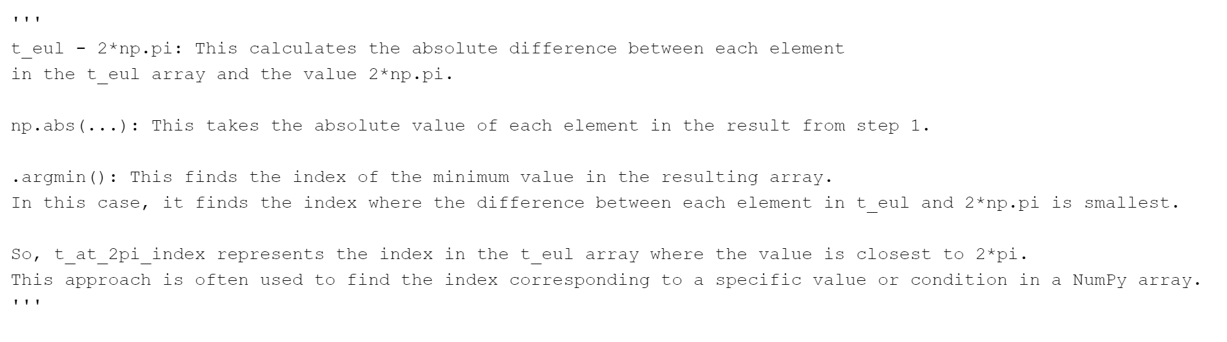

### Answer 4c)d)

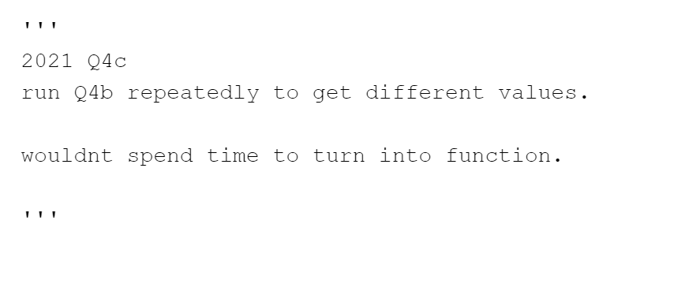

# 2022 Past Paper

## Question 1

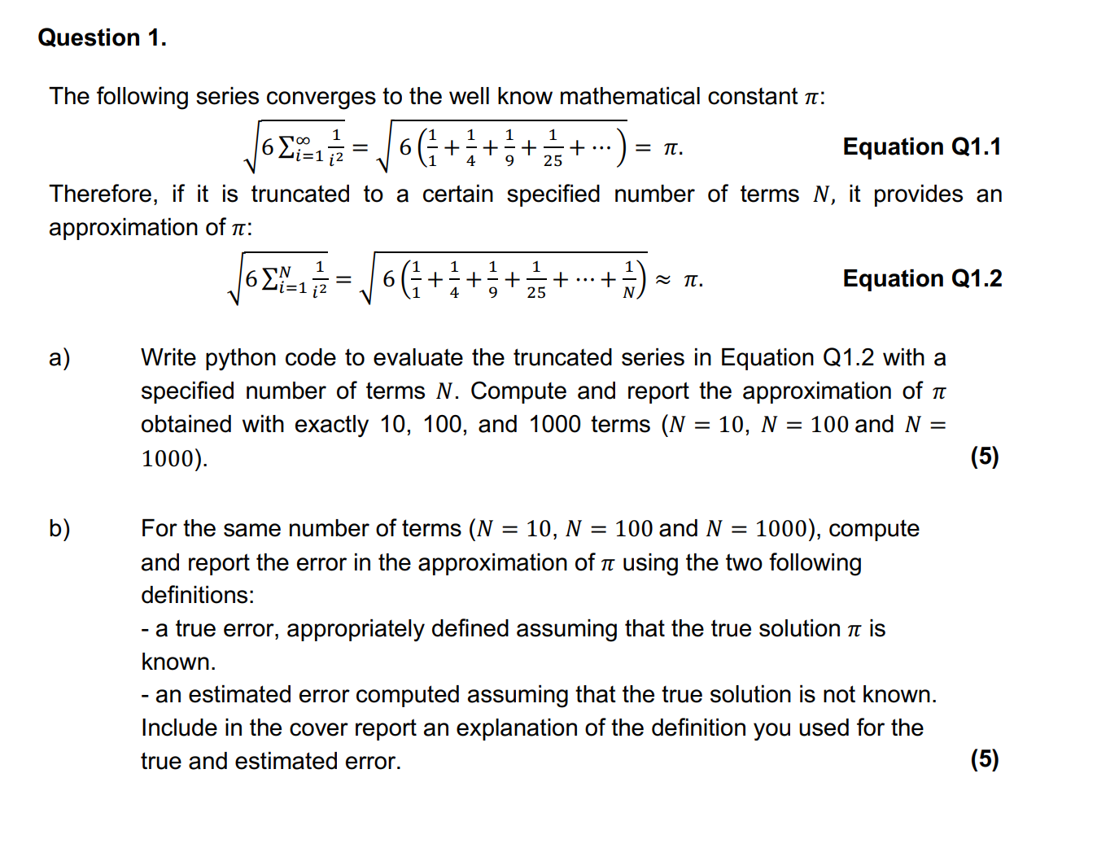

### Answer 1a)

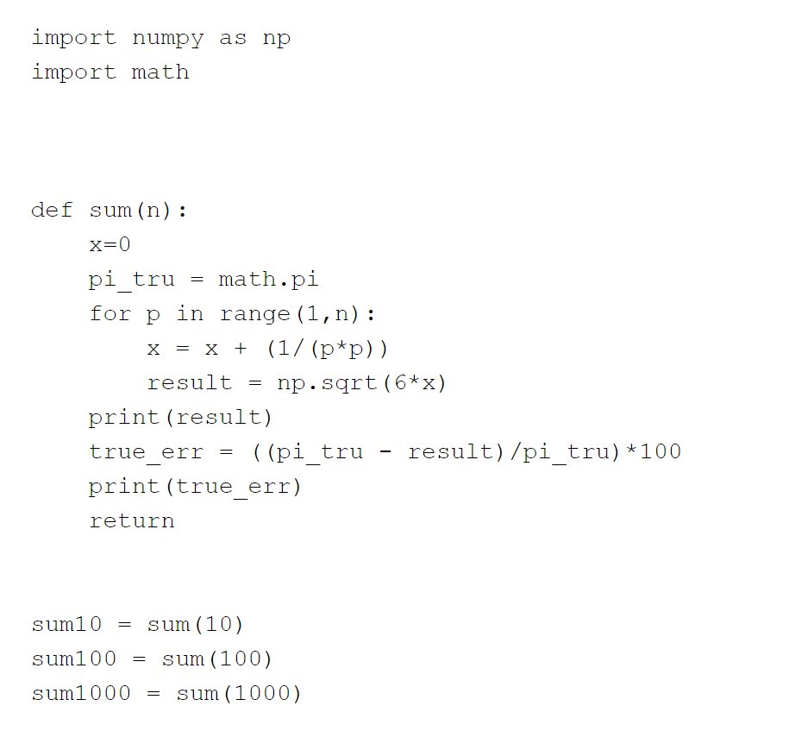

### Question 1b)

## Question 2

**\*\*\* JUST COPY AND PASTE FROM BENS FOLDER\*\*\***

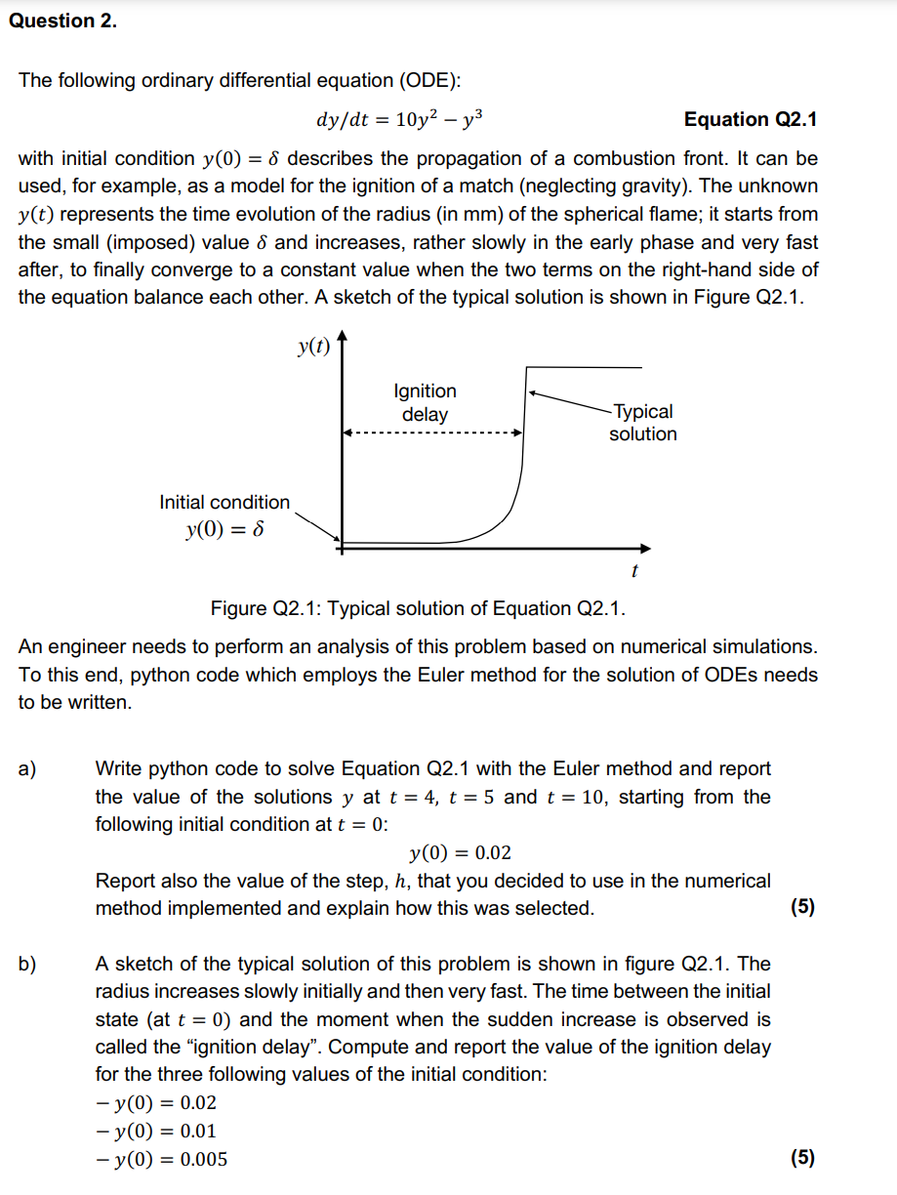

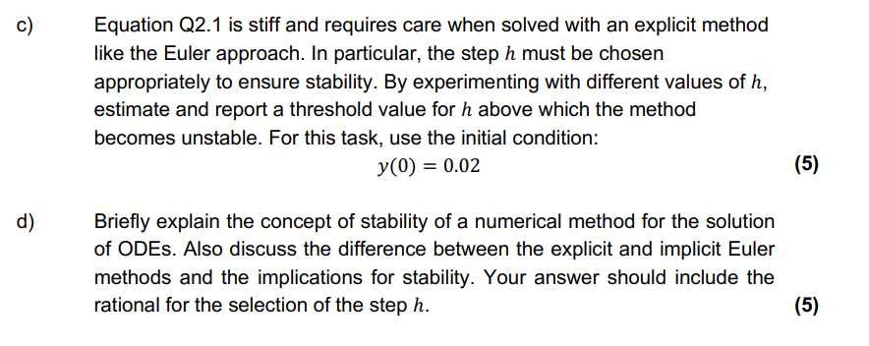

Answer 2a)  
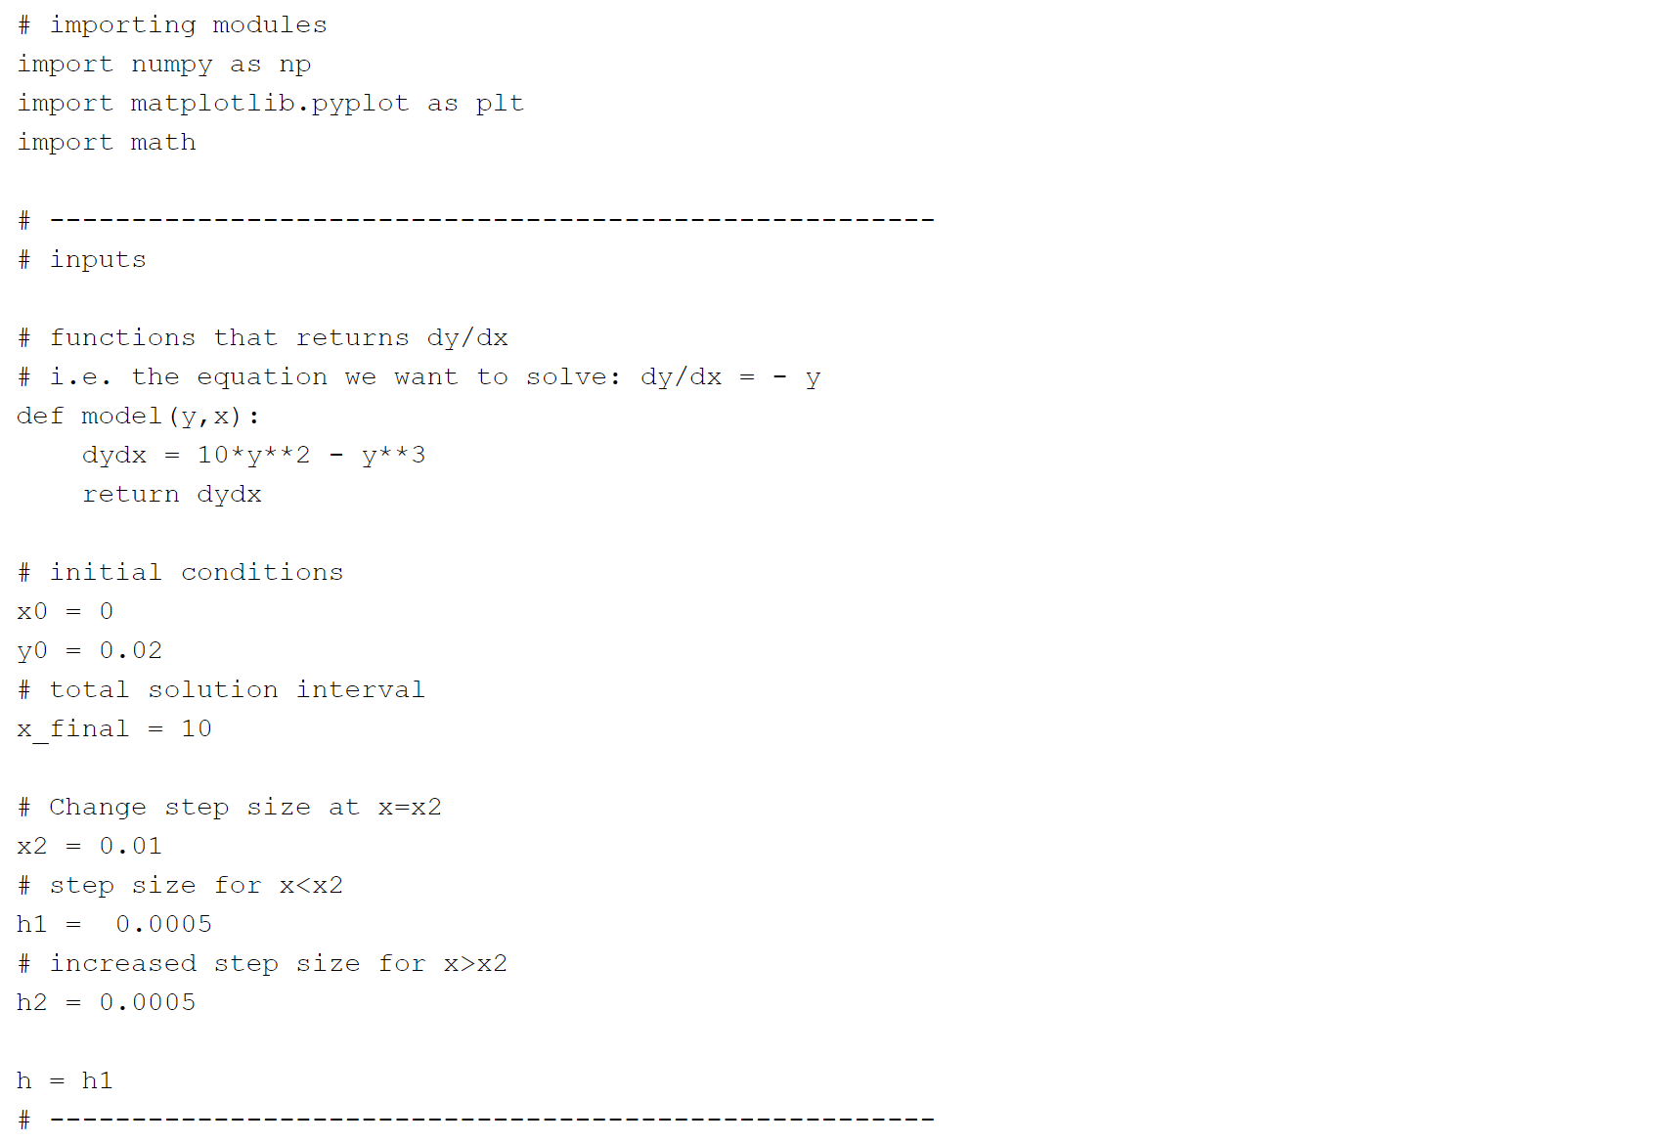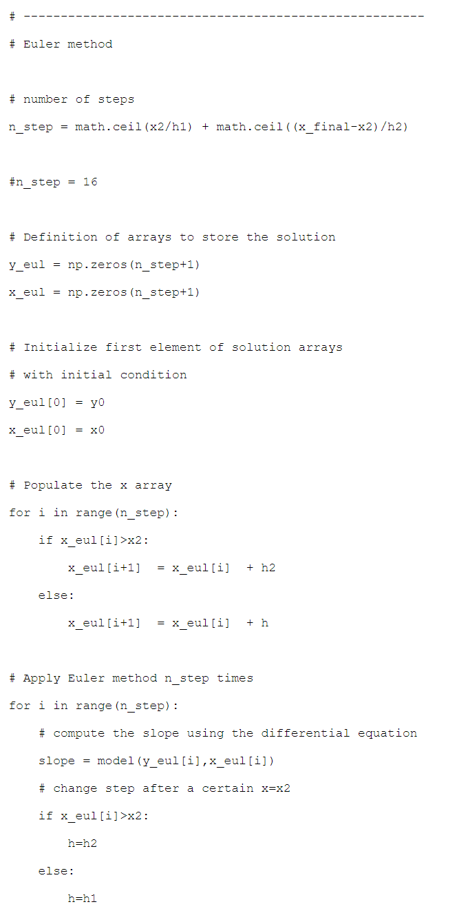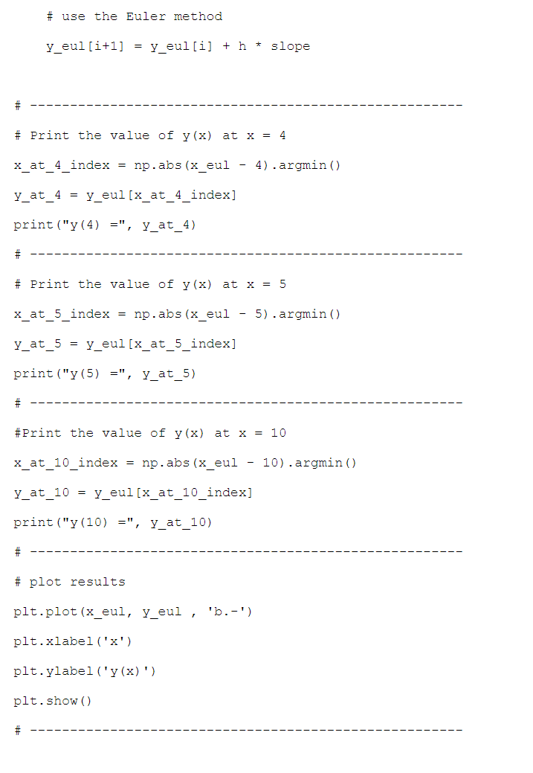

### Answer 2b)

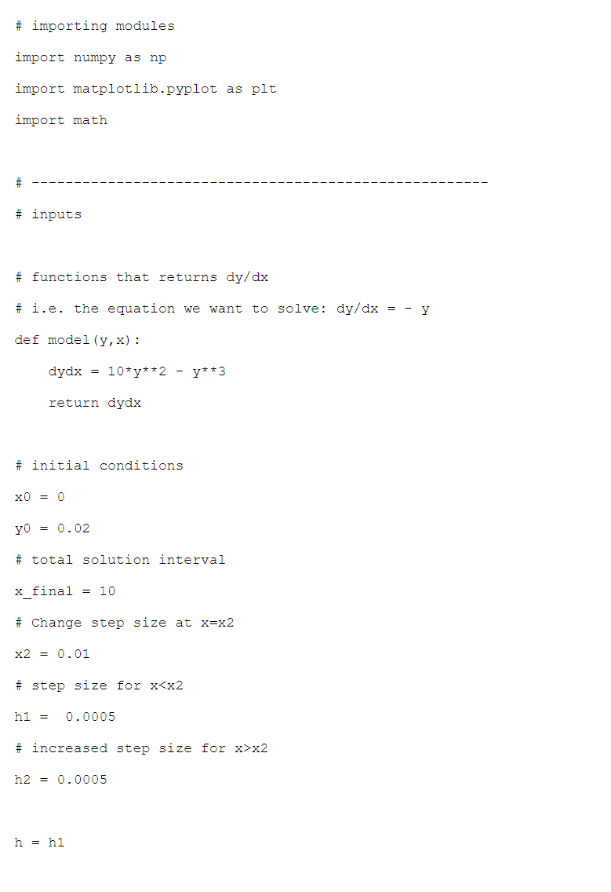

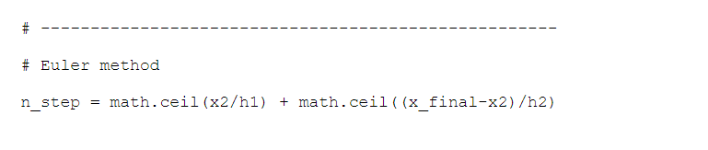

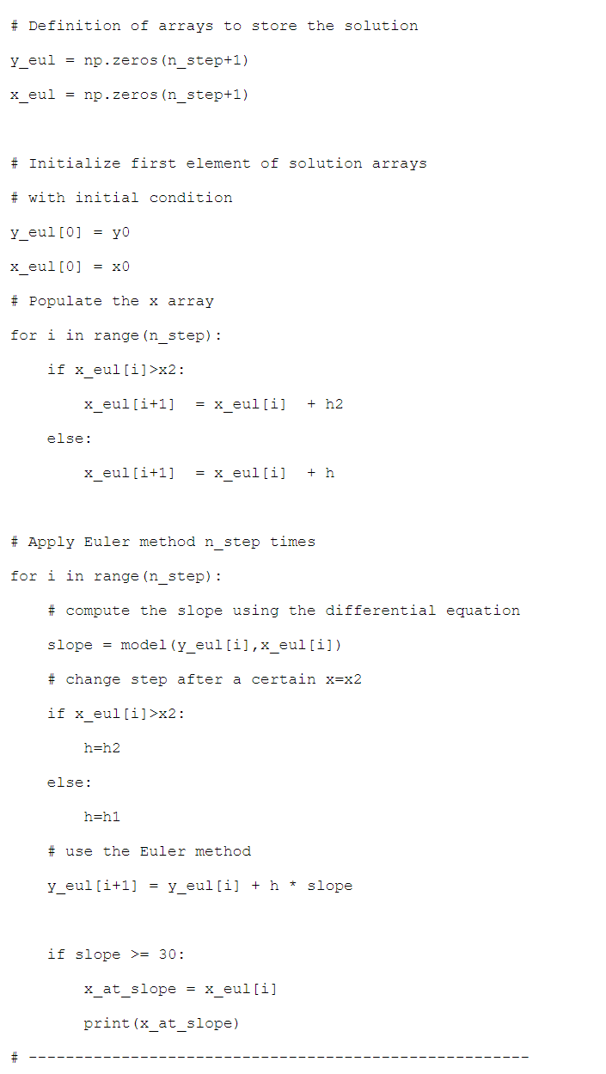

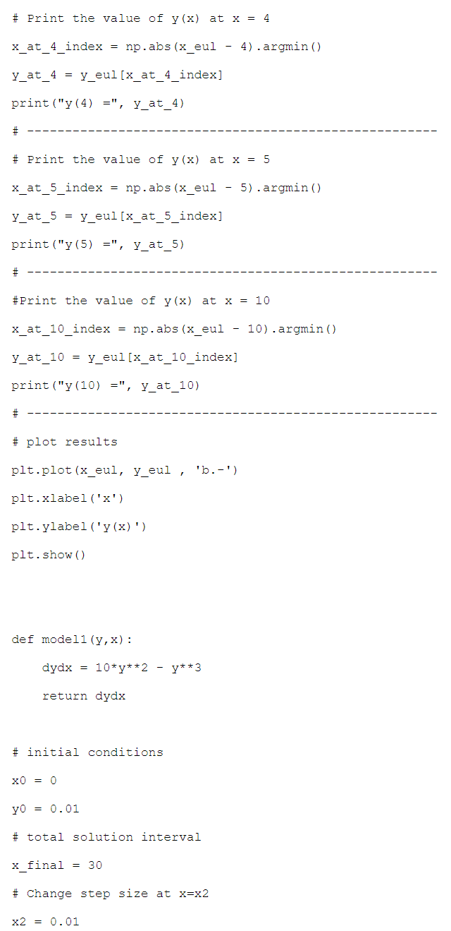

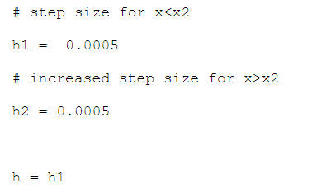

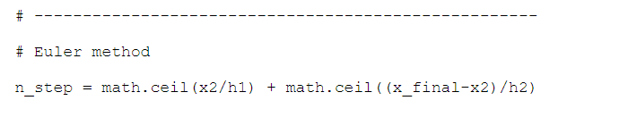

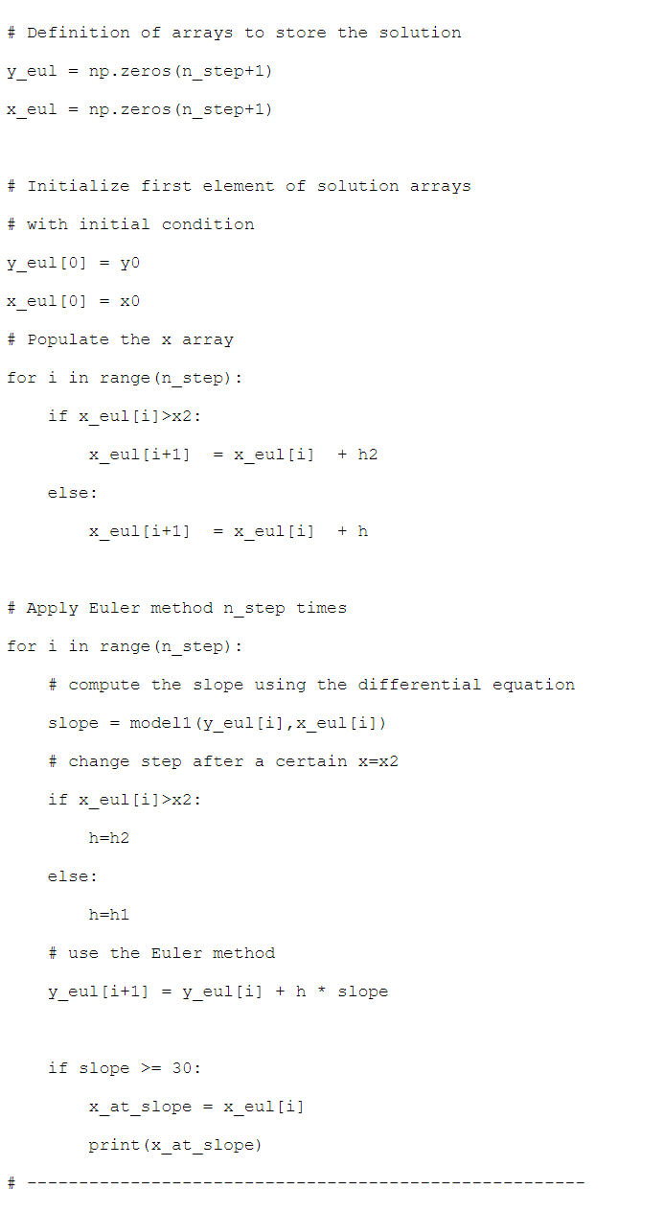

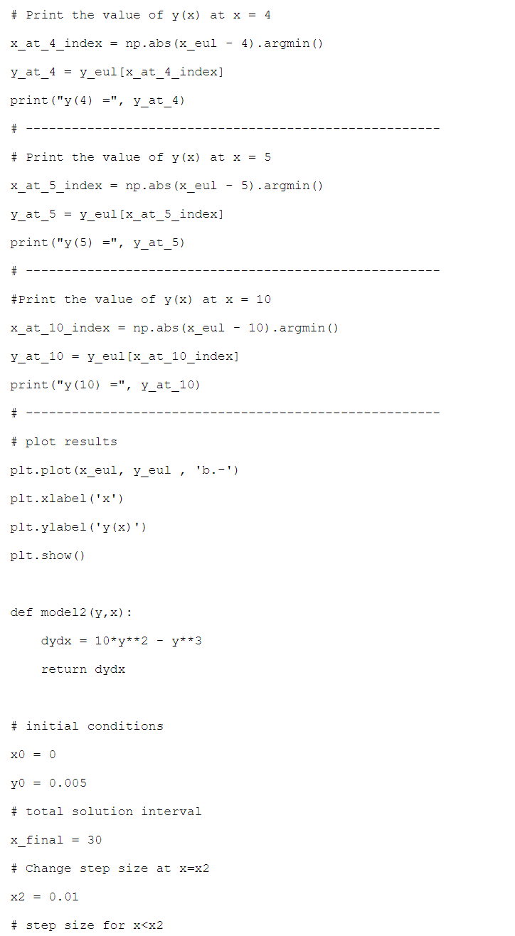

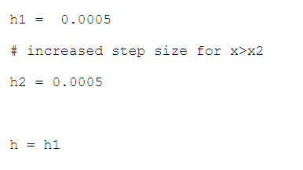

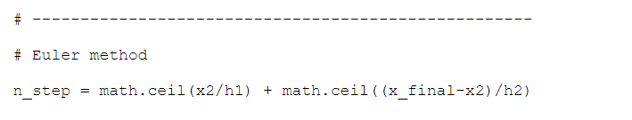

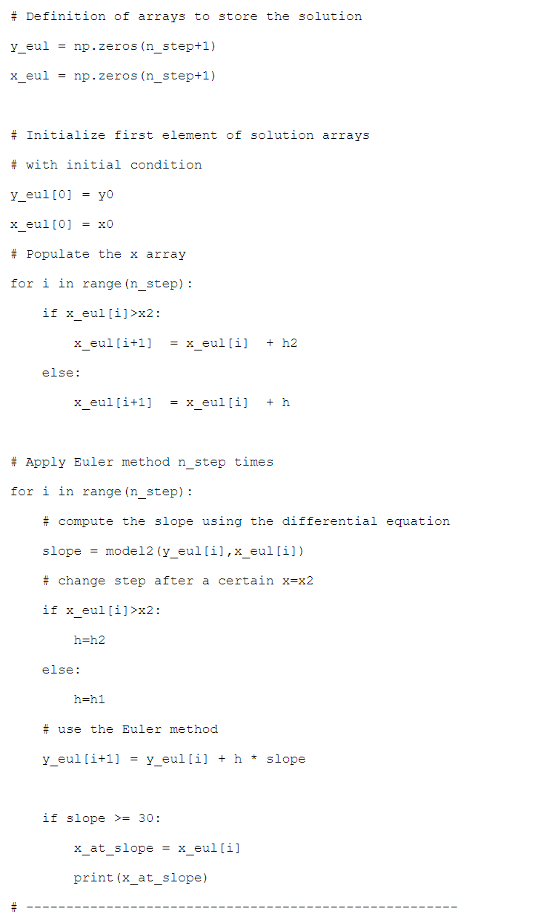

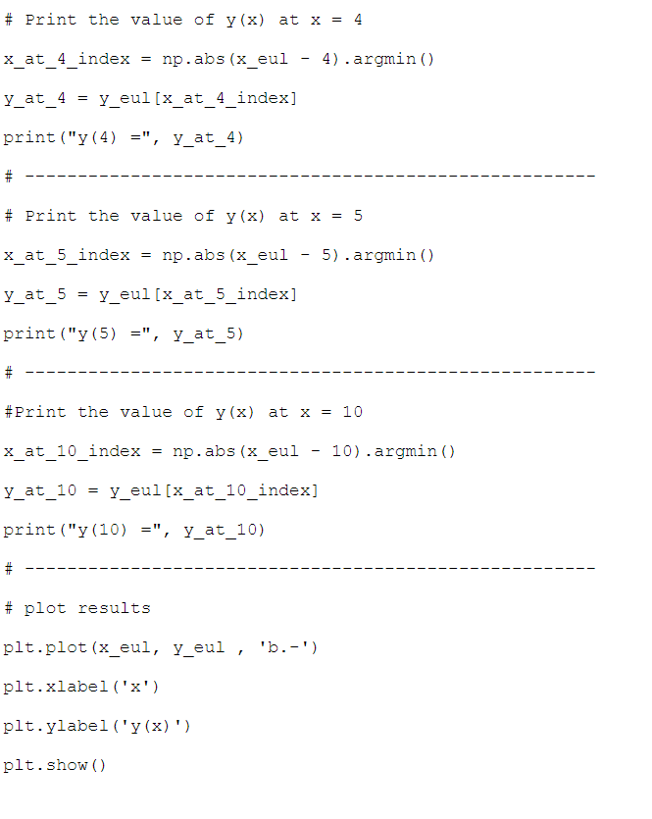

### Answer 2c)

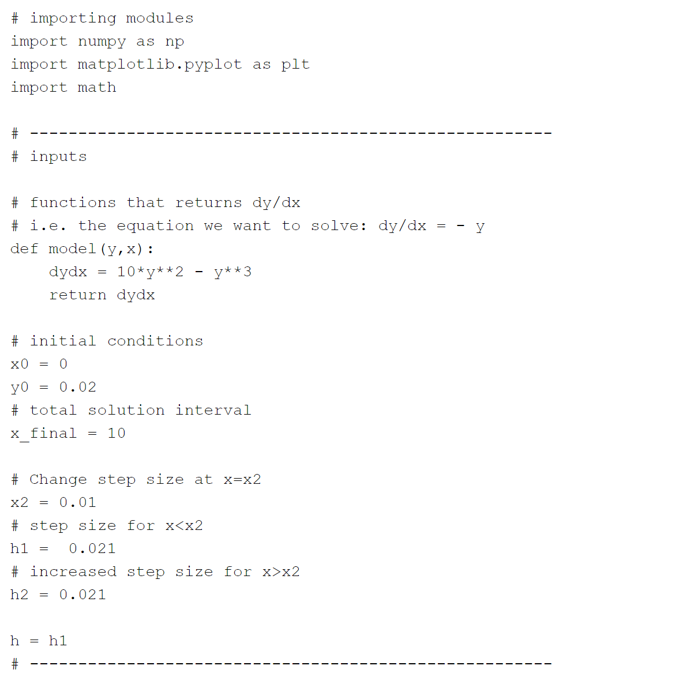

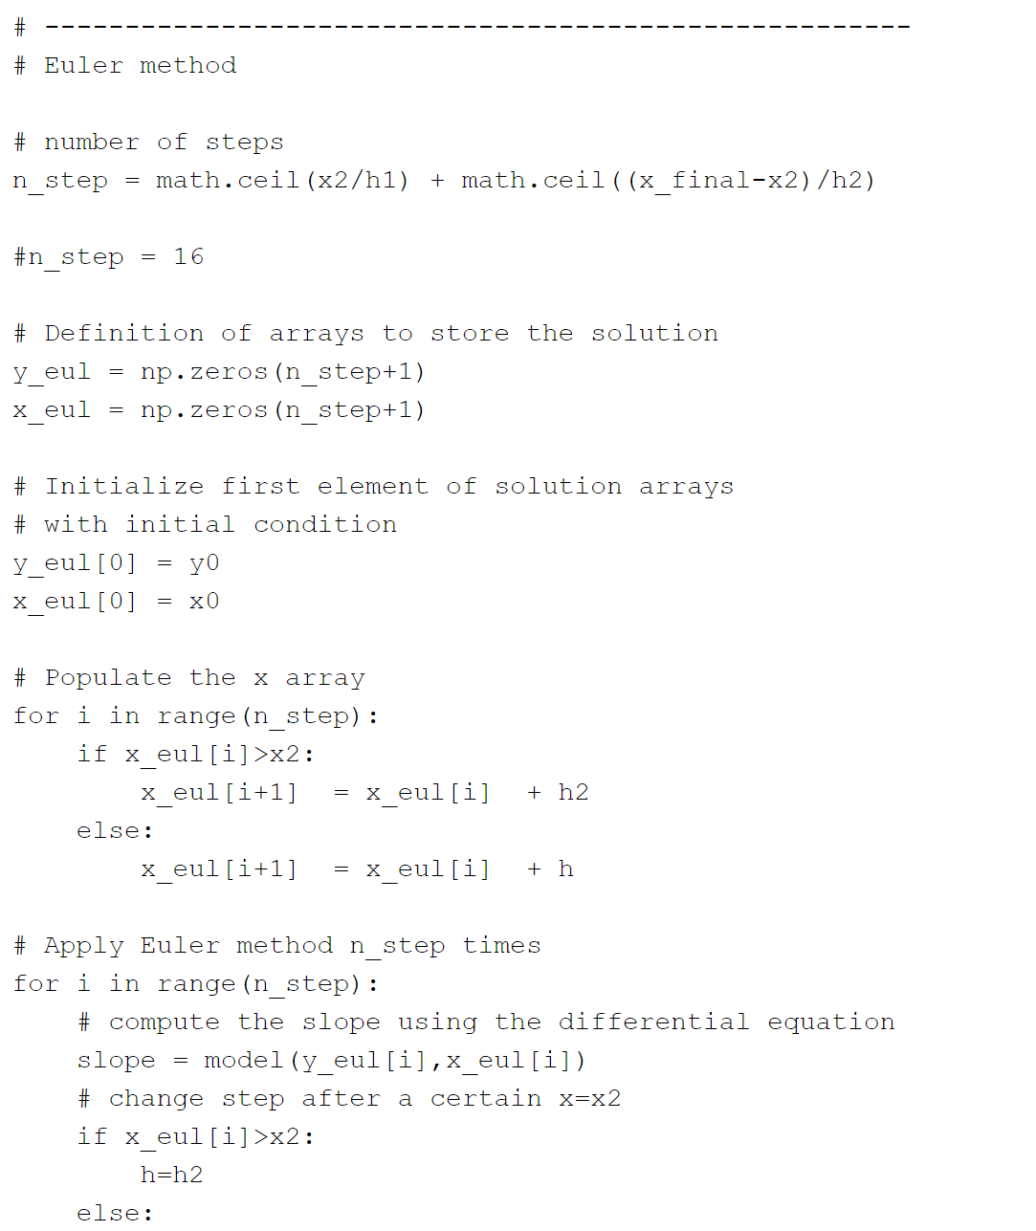

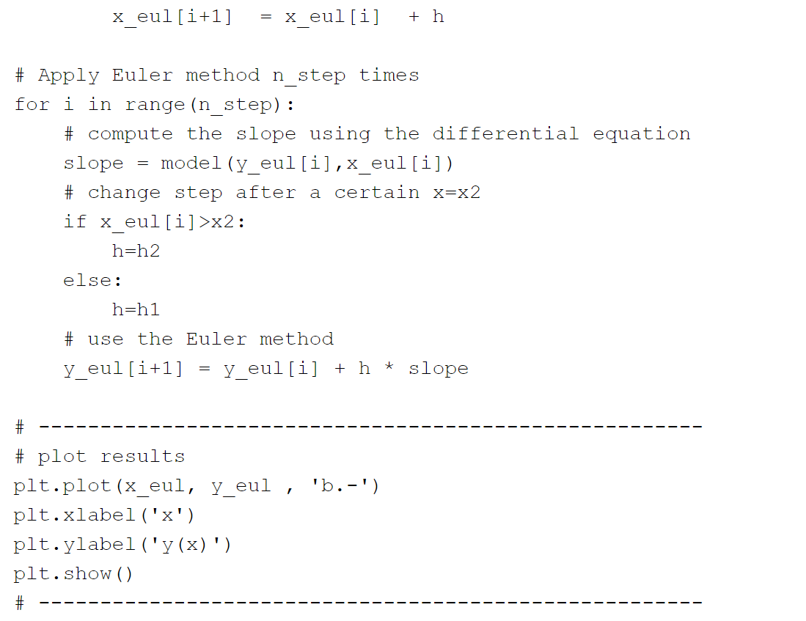

## Question 3

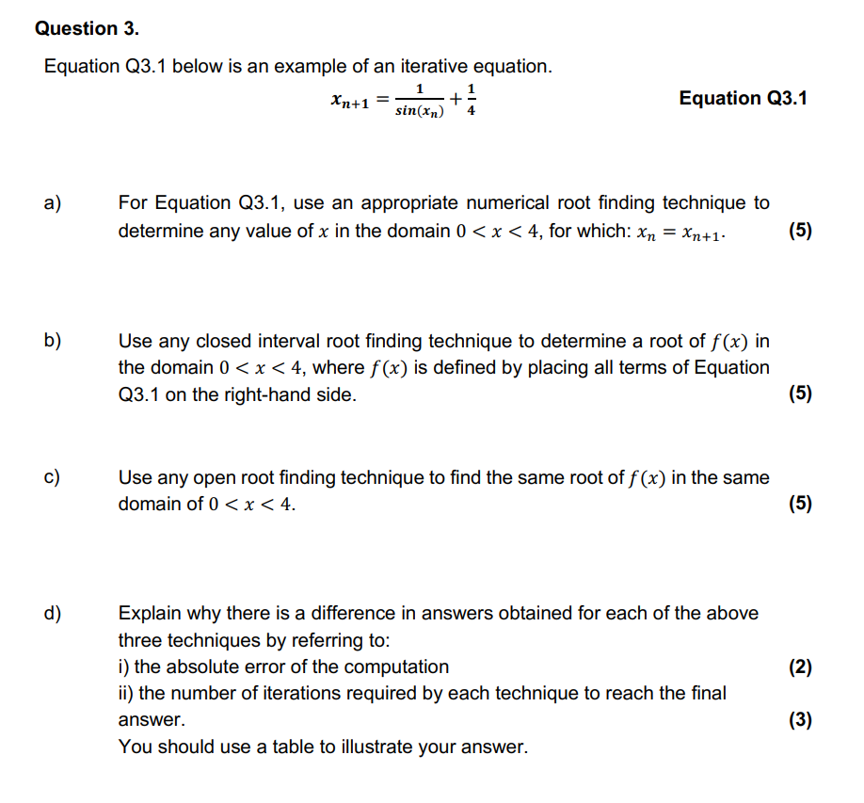

### Answer 3a)

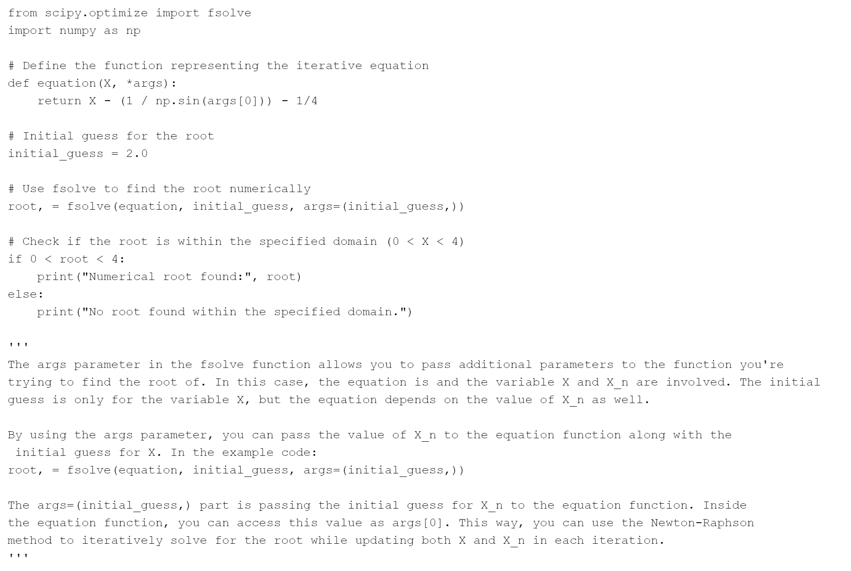

## Question 4

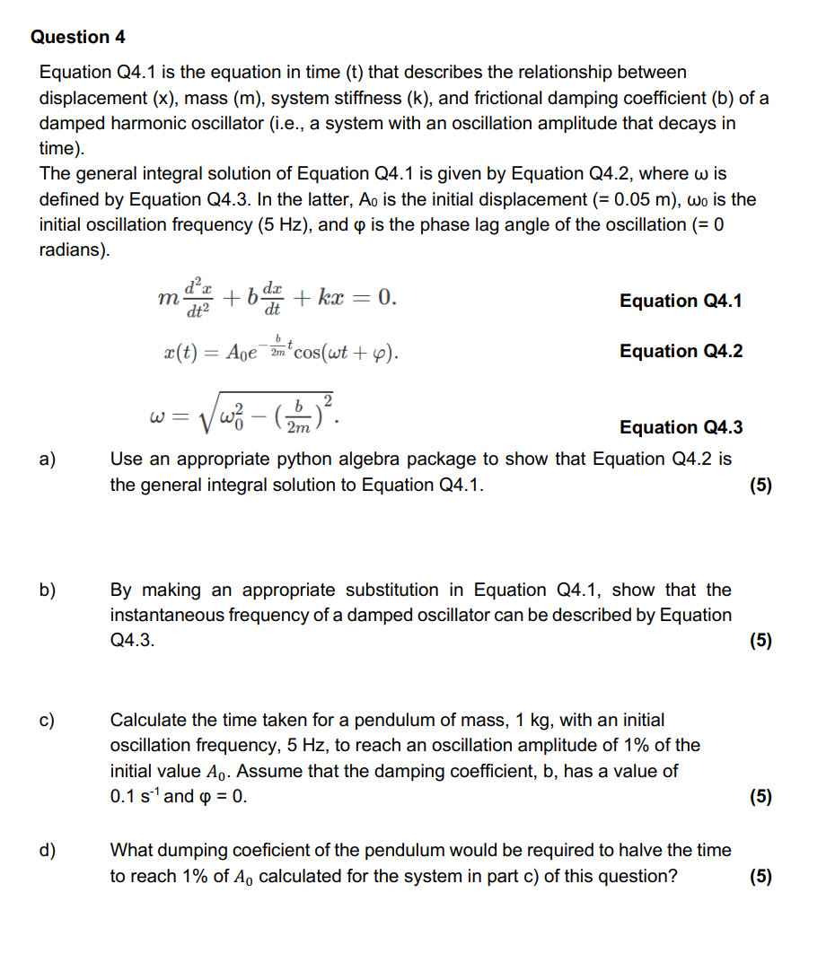

### Answer 4a)

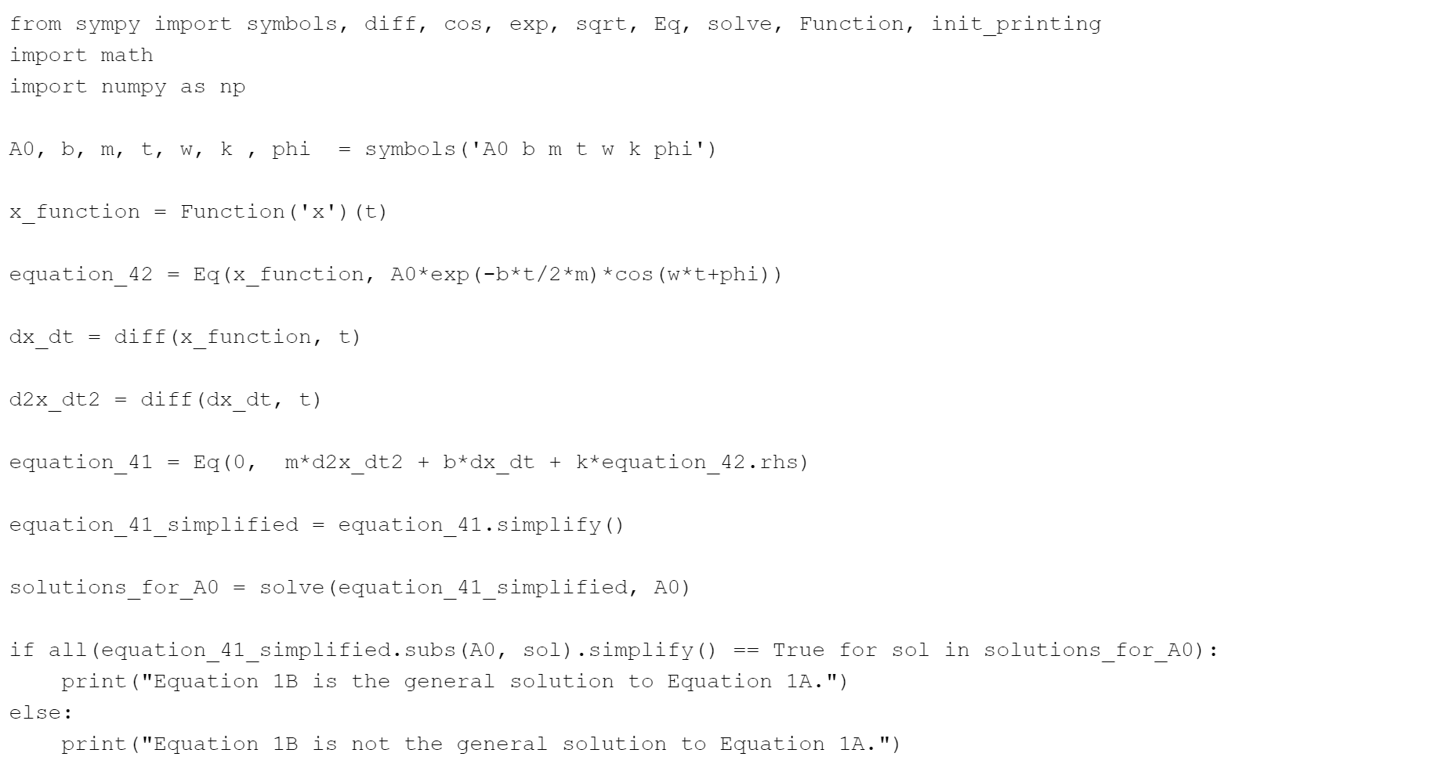

### Answer 4b)c)d)

